The Festival of the Reformation

St. John’s

Lutheran Church and School

200 Charleston Avenue Mattoon, Illinois 61938-4428

Church (217) 234-4923 School (217) 234-4911 Fax (217) 234-4925

www.stjohns-mattoon.org

Sunday, October 25, 2020, 8:00AM

See the back page for special instruction and notes about this worship service.

Prelude
Organ Es ist das Heil uns kommen her Unknown
(“Salvation unto Us Has Come”)
Brass Quintet Ein Feste Burg ist Unser Gott arr. Scott Harris
“A Mighty Fortress Is Our God”

Opening Hymn
656 A Mighty Fortress Is Our God (choir sings st. 2; setting by J.S. Bach)
Stand for the last stanza.
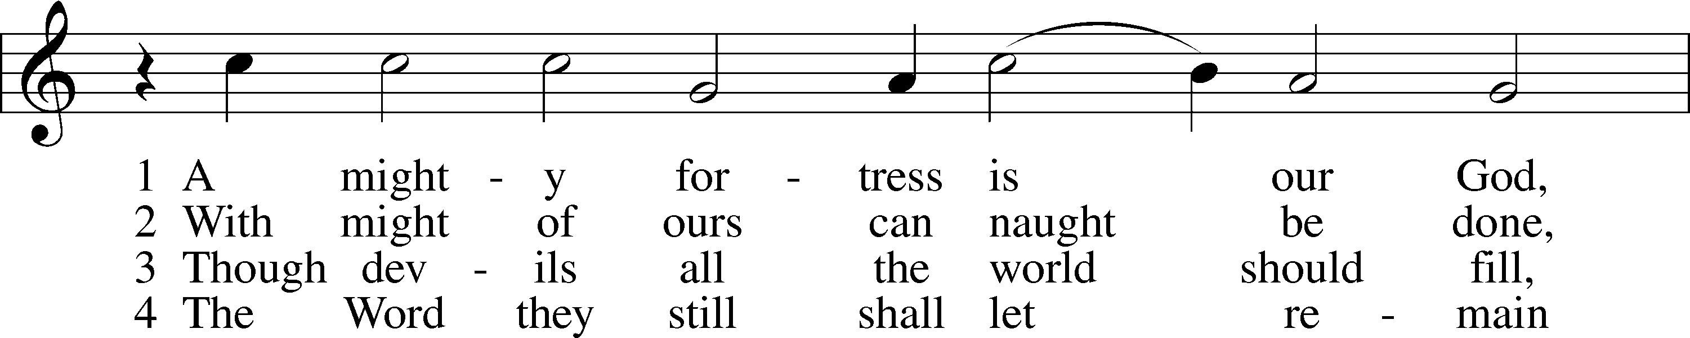
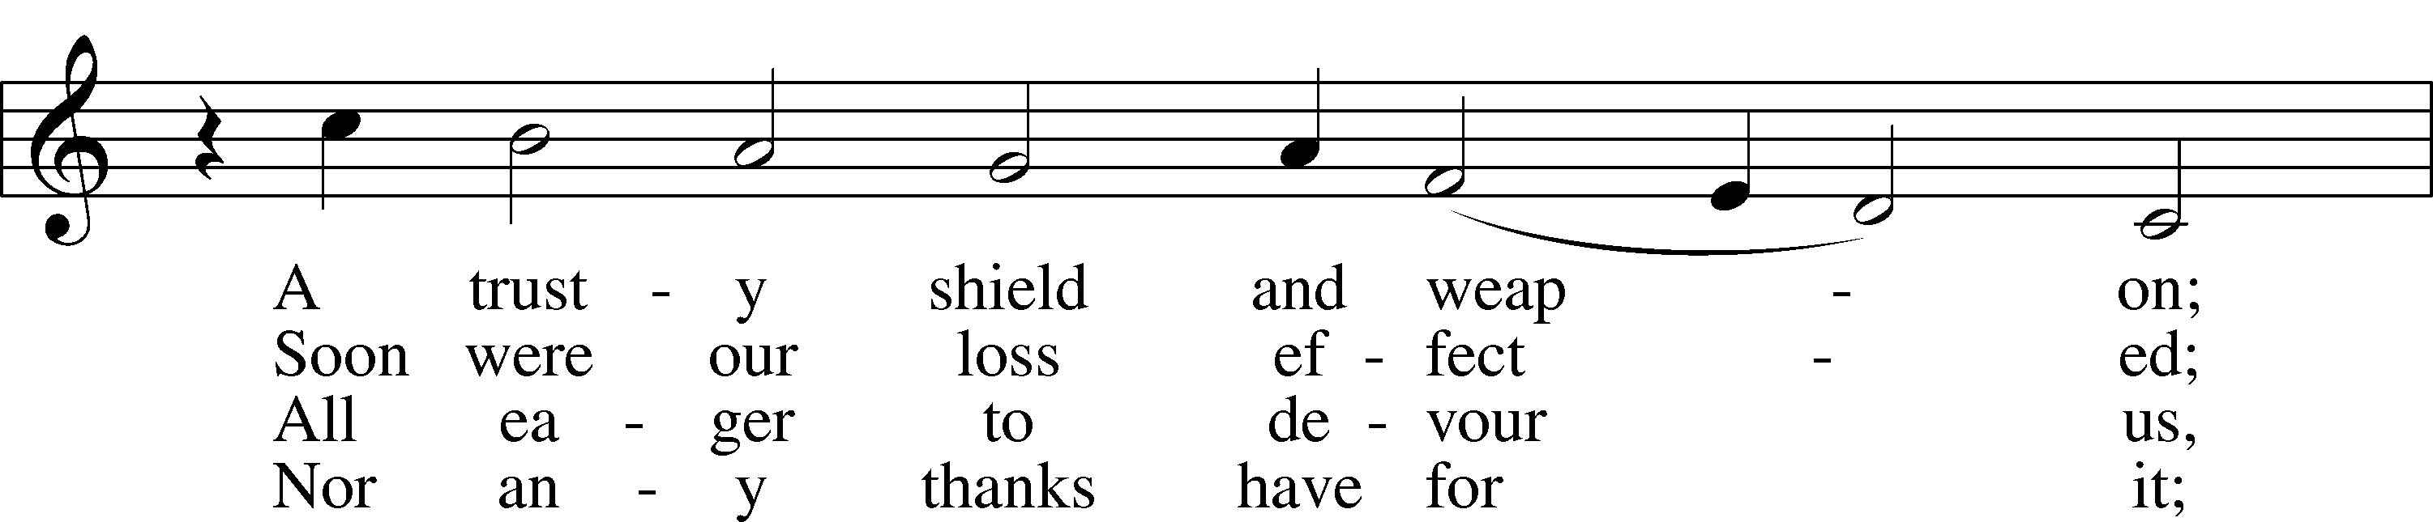
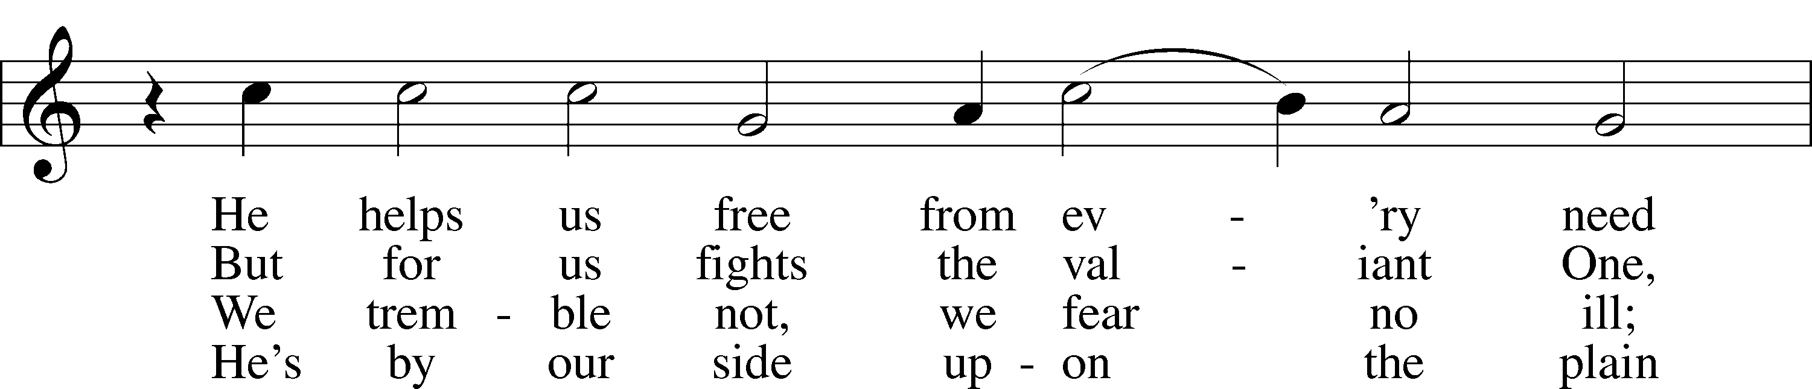
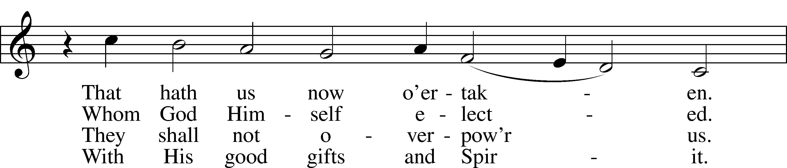
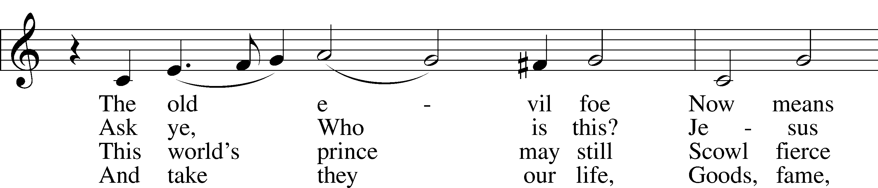
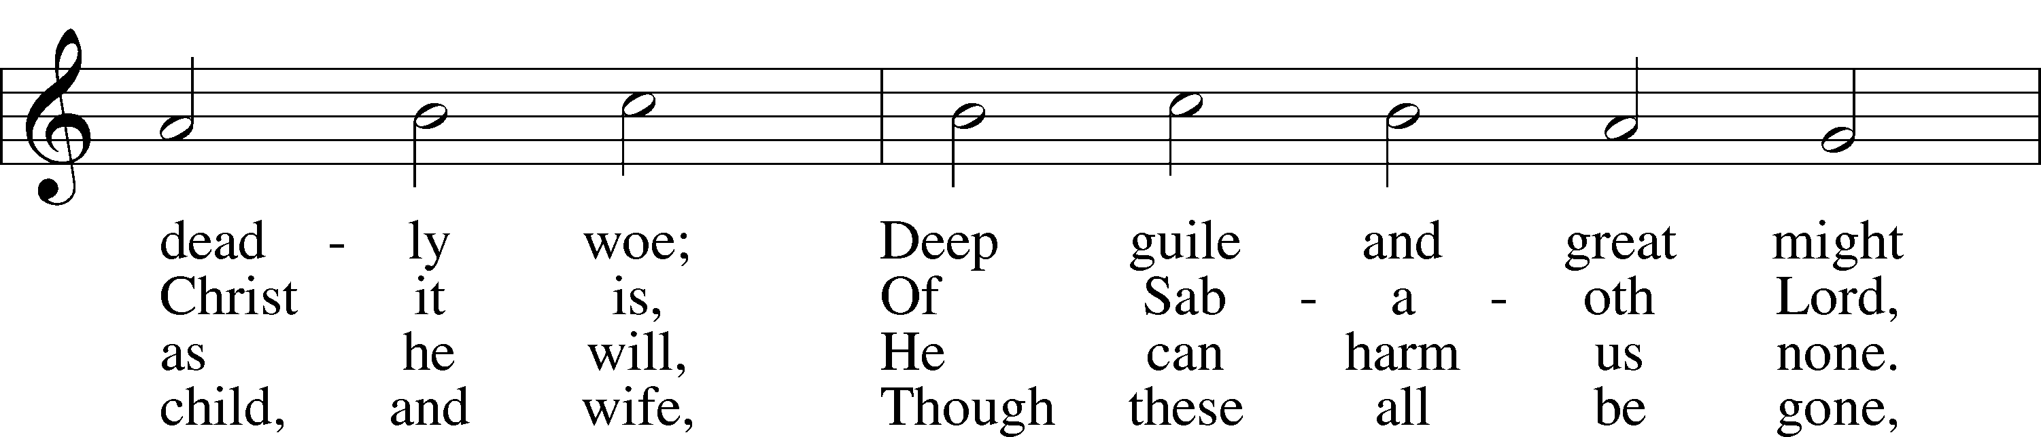
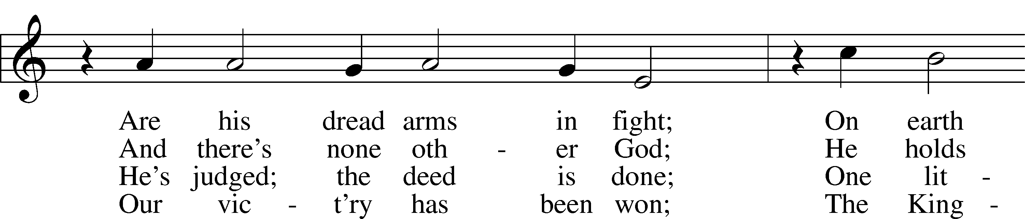
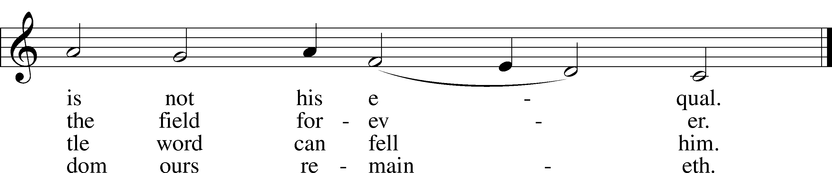

Confession and Absolution
The sign of the cross T may be made by all in remembrance of their Baptism.
P In the name of the Father and of the T Son and of the Holy Spirit.
C Amen.
P Beloved in the Lord! Let us draw near with a true heart and confess our sins unto God our Father, beseeching Him in the name of our Lord Jesus Christ to grant us forgiveness.
P Our help is in the name of the Lord,
C who made heaven and earth.
P I said, I will confess my transgressions unto the Lord,
C and You forgave the iniquity of my sin.
Silence for reflection on God’s Word and for self-examination.
P O almighty God, merciful Father,
C I, a poor, miserable sinner, confess unto You all my sins and iniquities with which I have ever offended You and justly deserved Your temporal and eternal punishment. But I am heartily sorry for them and sincerely repent of them, and I pray You of Your boundless mercy and for the sake of the holy, innocent, bitter sufferings and death of Your beloved Son, Jesus Christ, to be gracious and merciful to me, a poor, sinful being.
P Upon this your confession, I, by virtue of my office, as a called and ordained servant of the Word, announce the grace of God unto all of you, and in the stead and by the command of my Lord Jesus Christ I forgive you all your sins in the name of the Father and of the T Son and of the Holy Spirit.
C Amen.
Reformation Reflection:
“When our Lord and Master Jesus Christ said, ‘Repent,’ he willed the entire life of believers to be one of repentance.”
The First of Dr. Martin Luther’s 95 Theses
Service of the Word
Introit (sung by choir) Psalm 46
[Anonymous choral setting based on Luther’s Ein’ Feste Burg.]

¹God is our refuge and strength,
a very present help in trouble.
²Therefore we will not fear though the earth gives way,
though the mountains be moved into the heart of the sea,
³though its waters roar and foam,
though the mountains tremble at its swelling.
⁴There is a river whose streams make glad the city of God,
the holy habitation of the Most High.
⁵God is in the midst of her; she shall not be moved;
God will help her when morning dawns.
⁶The nations rage, the kingdoms totter;
he utters his voice, the earth melts.

⁷The Lord of hosts is with us;
the God of Jacob is our fortress.

⁸Come, behold the works of the Lord,
how he has brought desolations on the earth.
⁹He makes wars cease to the end of the earth;
he breaks the bow and shatters the spear;
he burns the chariots with fire.
¹⁰“Be still, and know that I am God.
I will be exalted among the nations,
I will be exalted in the earth!”

¹¹The Lord of hosts is with us;
the God of Jacob is our fortress.
Kyrie LSB 186
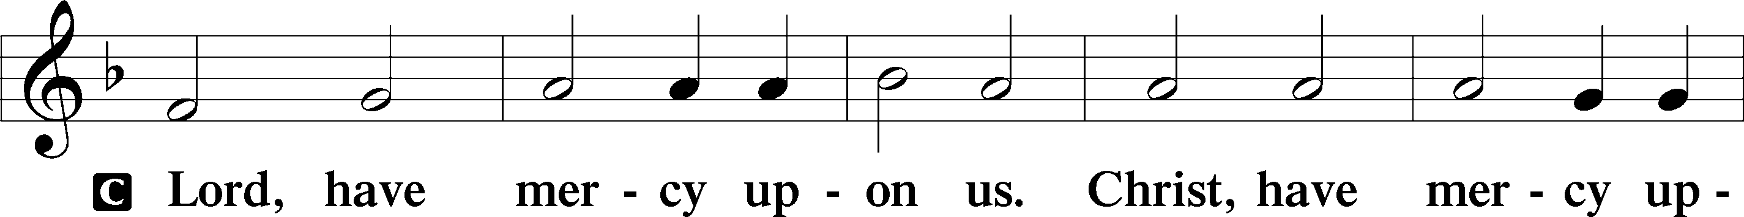
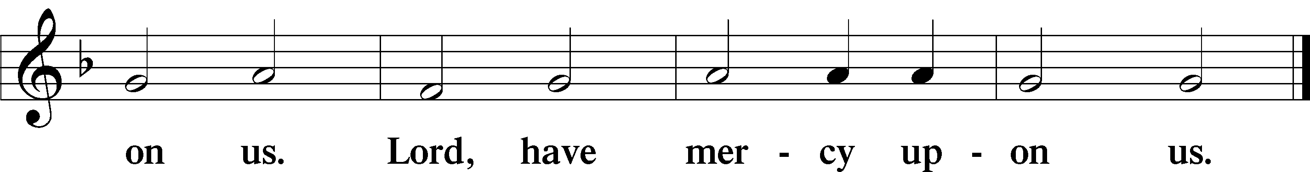
Gloria in Excelsis LSB 187
P Glory be to God on high:
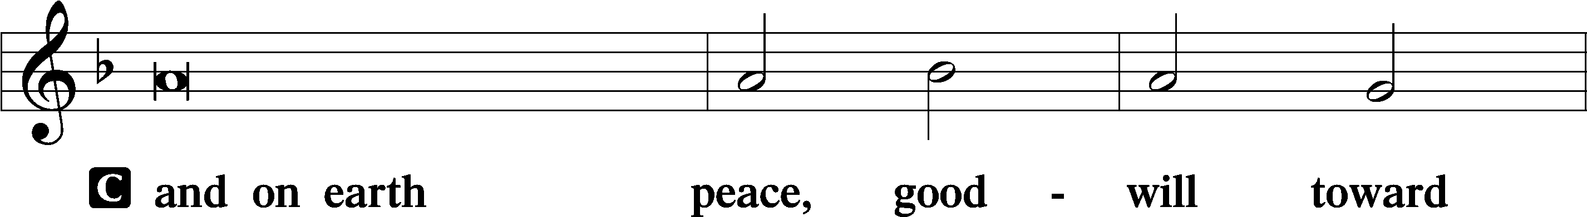
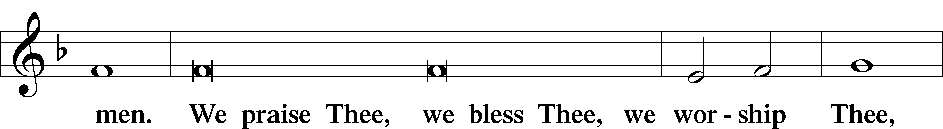
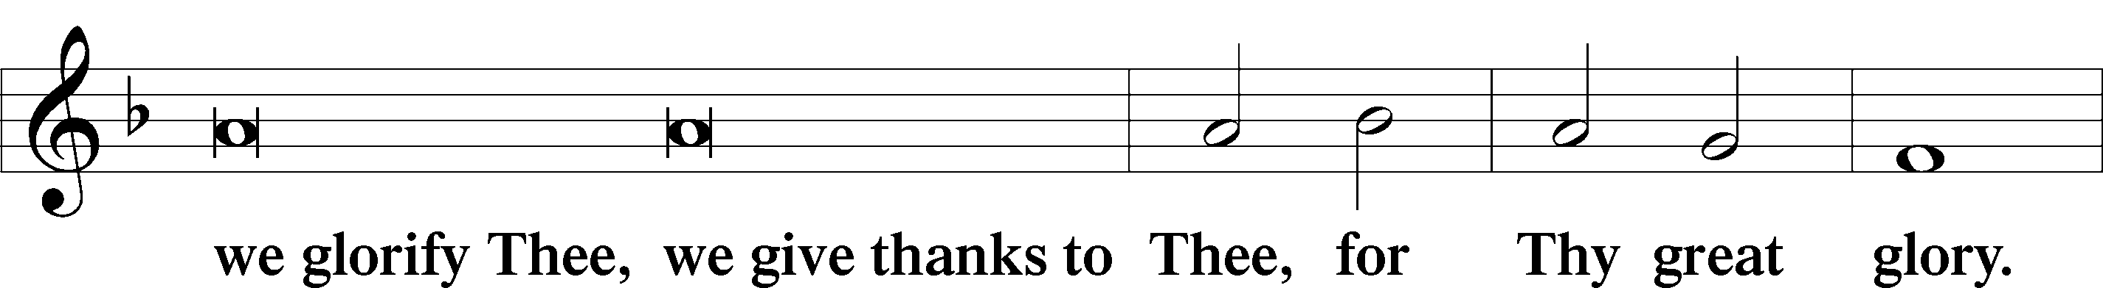
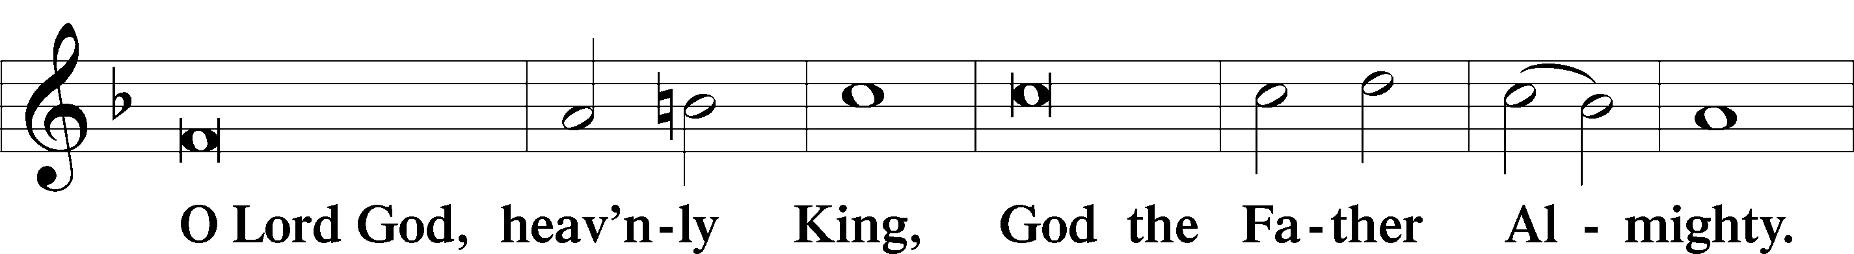
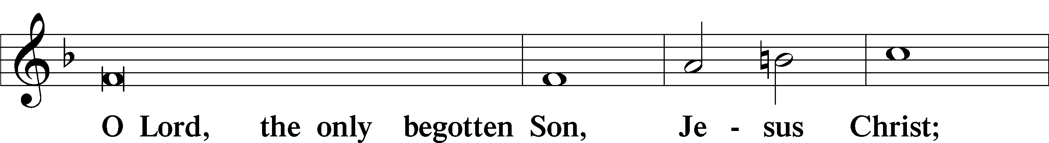
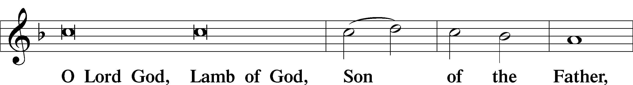
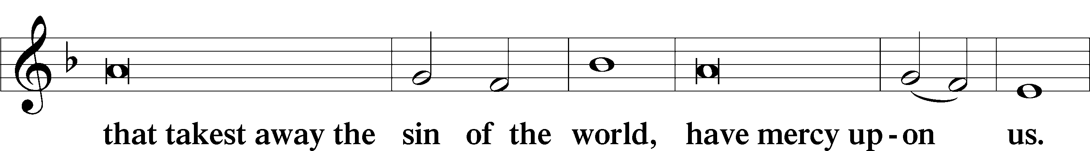
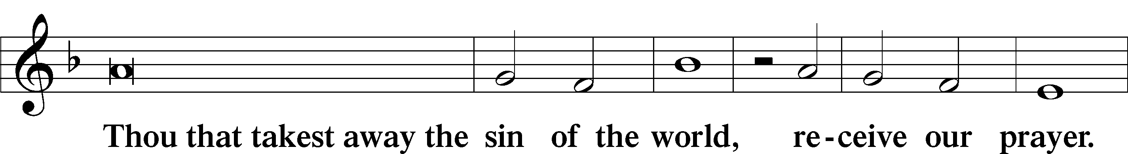
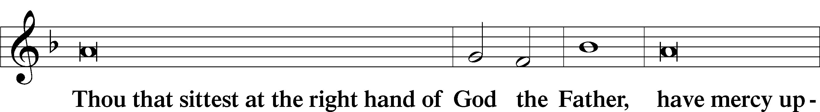
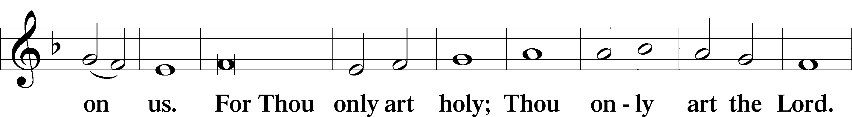
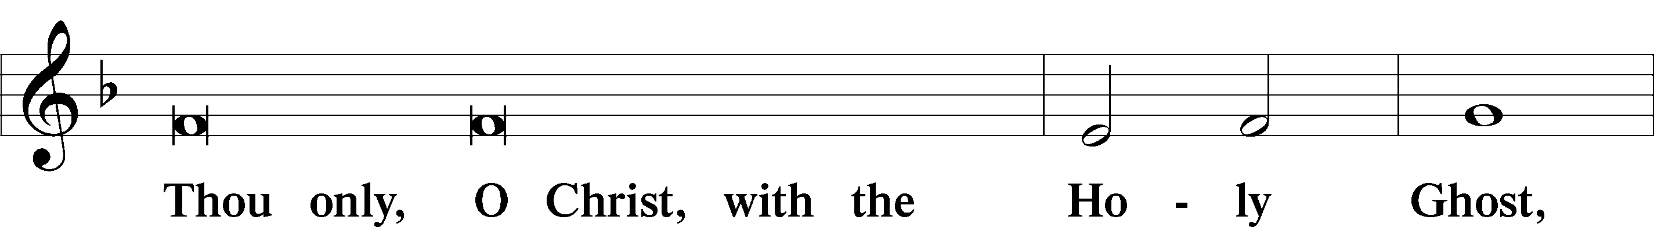
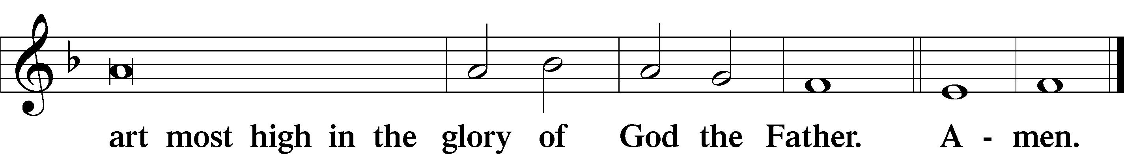
Salutation and Collect of the Day
P The Lord be with you.
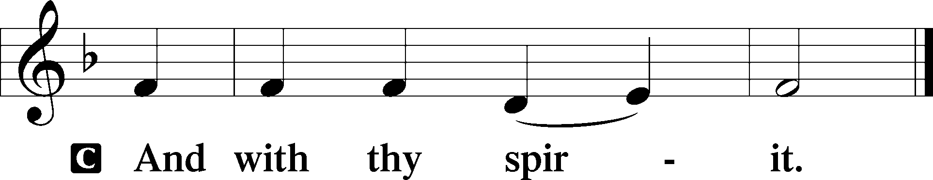
P Let us pray.
Almighty and gracious Lord, pour out Your Holy Spirit on Your faithful people. Keep us steadfast in Your grace and truth, protect and deliver us in times of temptation, defend us against all enemies, and grant to Your Church Your saving peace; through Jesus Christ, Your Son, our Lord, who lives and reigns with You and the Holy Spirit, one God, now and forever.
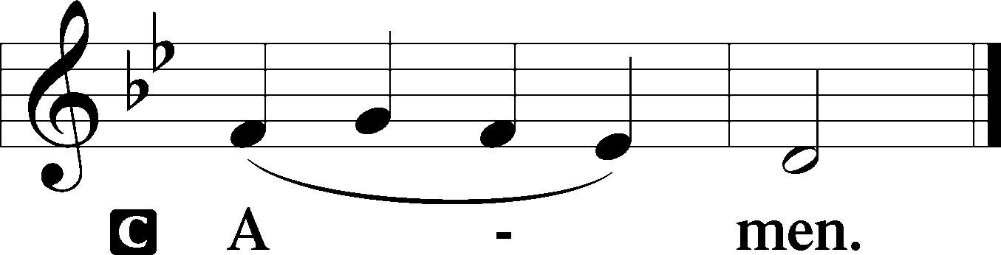

Sit
First Reading Revelation 14:6–7
⁶Then I saw another angel flying directly overhead, with an eternal gospel to proclaim to those who dwell on earth, to every nation and tribe and language and people. ⁷And he said with a loud voice, “Fear God and give him glory, because the hour of his judgment has come, and worship him who made heaven and earth, the sea and the springs of water.”
P This is the Word of the Lord.
C Thanks be to God.
Gradual (sung by choir) Psalm 122:1, 7; 117:1
I was glad when they said unto me:
Let us go into the house of the Lord.
Peace be with-in Thy walls:
and prosperity within Thy palaces. Alleluia! Alleluia!
Oh, praise the Lord, all ye nations:
praise Him, all ye people. Alleluia!
Epistle Romans 3:19–28
¹⁹Now we know that whatever the law says it speaks to those who are under the law, so that every mouth may be stopped, and the whole world may be held accountable to God. ²⁰For by works of the law no human being will be justified in his sight, since through the law comes knowledge of sin.
²¹But now the righteousness of God has been manifested apart from the law, although the Law and the Prophets bear witness to it— ²²the righteousness of God through faith in Jesus Christ for all who believe. For there is no distinction: ²³for all have sinned and fall short of the glory of God, ²⁴and are justified by his grace as a gift, through the redemption that is in Christ Jesus, ²⁵whom God put forward as a propitiation by his blood, to be received by faith. This was to show God’s righteousness, because in his divine forbearance he had passed over former sins. ²⁶It was to show his righteousness at the present time, so that he might be just and the justifier of the one who has faith in Jesus.
²⁷Then what becomes of our boasting? It is excluded. By what kind of law? By a law of works? No, but by the law of faith. ²⁸For we hold that one is justified by faith apart from works of the law.
P This is the Word of the Lord.
C Thanks be to God.
Stand
Alleluia LSB 190
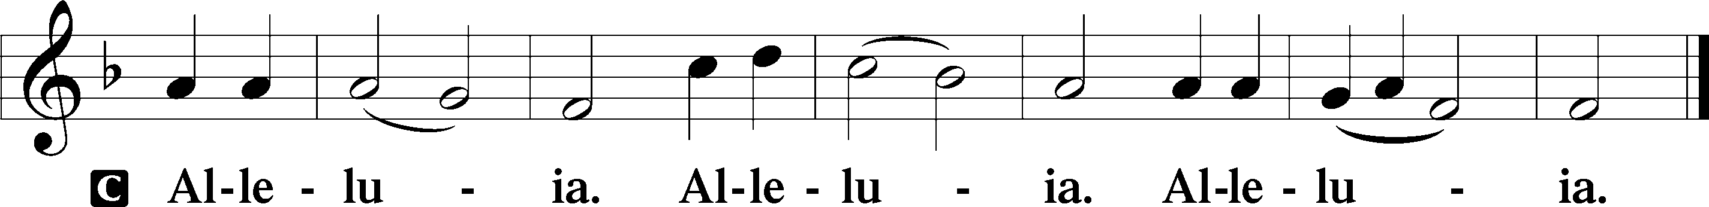

T
Holy Gospel Matthew 22:34–46
P The Holy Gospel according to St. Matthew, the twenty-second chapter.
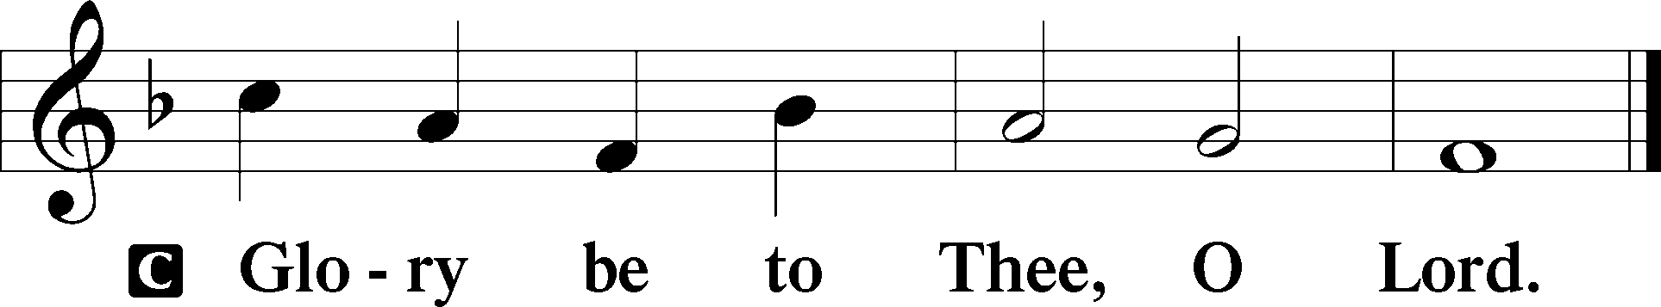
³⁴When the Pharisees heard that [Jesus] had silenced the Sadducees, they gathered together. ³⁵And one of them, a lawyer, asked him a question to test him. ³⁶“Teacher, which is the great commandment in the Law?” ³⁷And he said to him, “You shall love the Lord your God with all your heart and with all your soul and with all your mind. ³⁸This is the great and first commandment. ³⁹And a second is like it: You shall love your neighbor as yourself. ⁴⁰On these two commandments depend all the Law and the Prophets.”
⁴¹Now while the Pharisees were gathered together, Jesus asked them a question, ⁴²saying, “What do you think about the Christ? Whose son is he?” They said to him, “The son of David.” ⁴³He said to them, “How is it then that David, in the Spirit, calls him Lord, saying,
⁴⁴“‘The Lord said to my Lord,
Sit at my right hand,
until I put your enemies under your feet’?
⁴⁵If then David calls him Lord, how is he his son?” ⁴⁶And no one was able to answer him a word, nor from that day did anyone dare to ask him any more questions.
P This is the Gospel of the Lord.
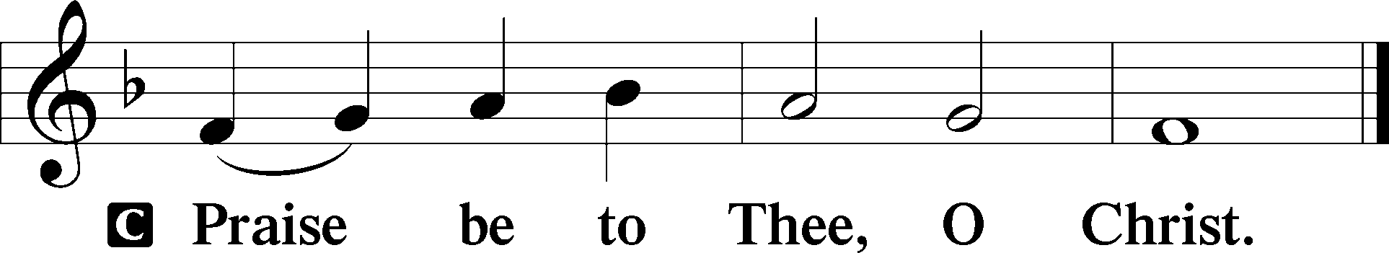
Nicene Creed
C I believe in one God,
the Father Almighty,
maker of heaven and earth
and of all things visible and invisible.
And in one Lord Jesus Christ,
the only-begotten Son of God,
begotten of His Father before all worlds,
God of God, Light of Light,
very God of very God,
begotten, not made,
being of one substance with the Father,
by whom all things were made;
who for us men and for our salvation came down from heaven
and was incarnate by the Holy Spirit of the virgin Mary
and was made man;
and was crucified also for us under Pontius Pilate.
He suffered and was buried.
And the third day He rose again according to the Scriptures
and ascended into heaven
and sits at the right hand of the Father.
And He will come again with glory to judge both the living and the dead,
whose kingdom will have no end.
And I believe in the Holy Spirit,
the Lord and giver of life,
who proceeds from the Father and the Son,
who with the Father and the Son together is worshiped and glorified,
who spoke by the prophets.
And I believe in one holy Christian and apostolic Church,
I acknowledge one Baptism for the remission of sins,
and I look for the resurrection of the dead
and the life T of the world to come. Amen.
Sit

Reformation Reflection:
Also [our churches] teach that men cannot be justified before God by their own strength, merits, or works, but are freely justified for Christ’s sake, through faith, when they believe that they are received into favor, and that their sins are forgiven for Christ’s sake, who, by His death, has made satisfaction for our sins. This faith God imputes for righteousness in His sight. Rom. 3 and 4.
Augsburg Confession, Article 4, “Of Justification”
Hymn of the Day
555 Salvation unto Us Has Come, sts. 1–5 (choir sings sts. 2 and 4)
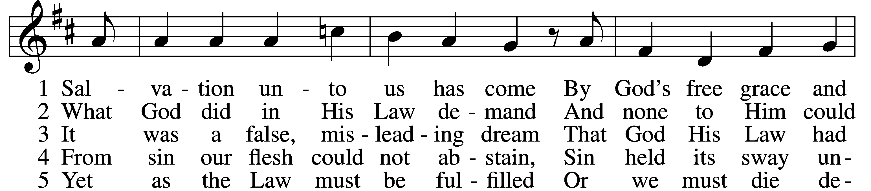
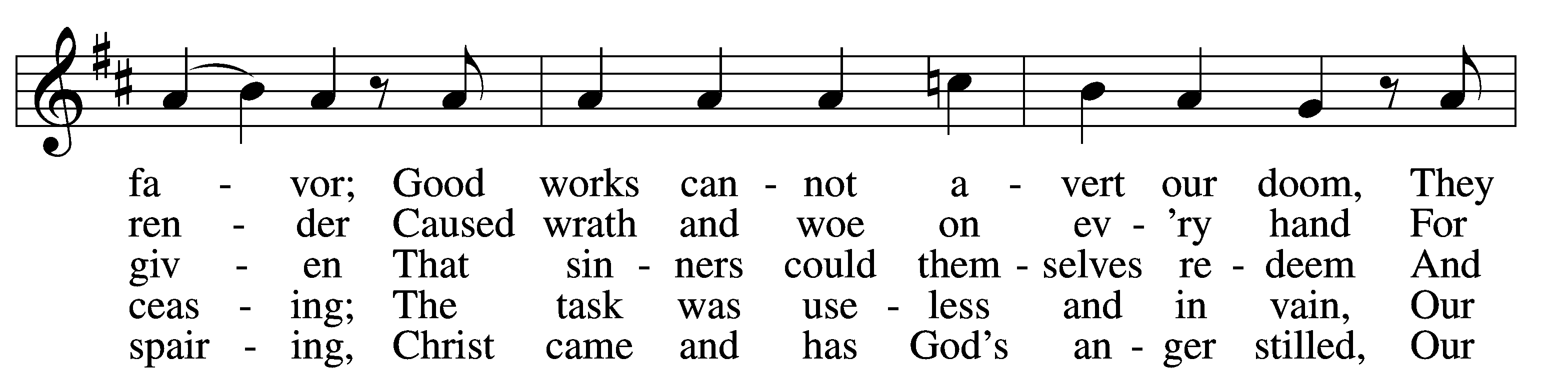
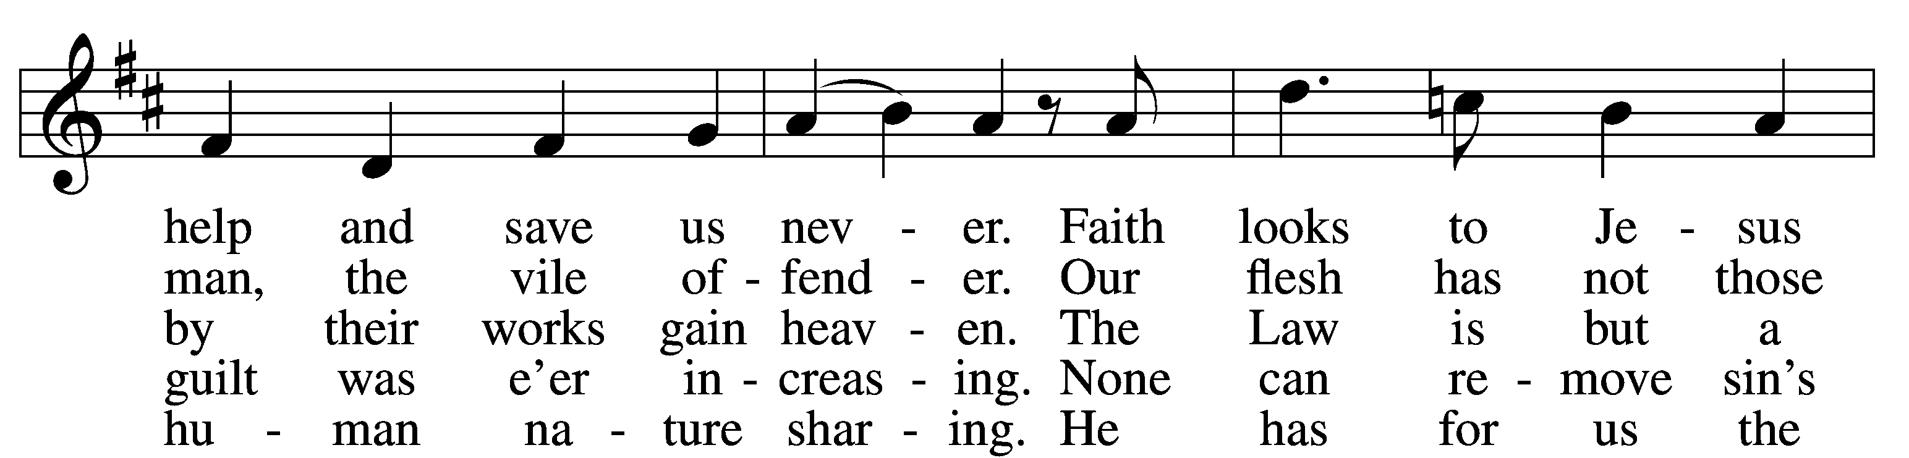
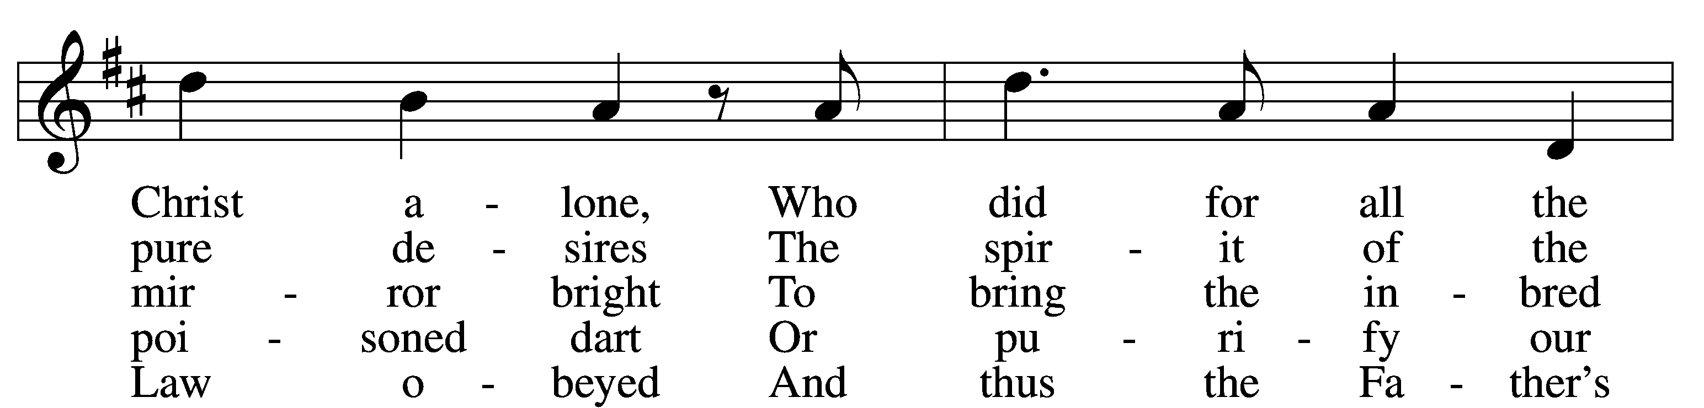
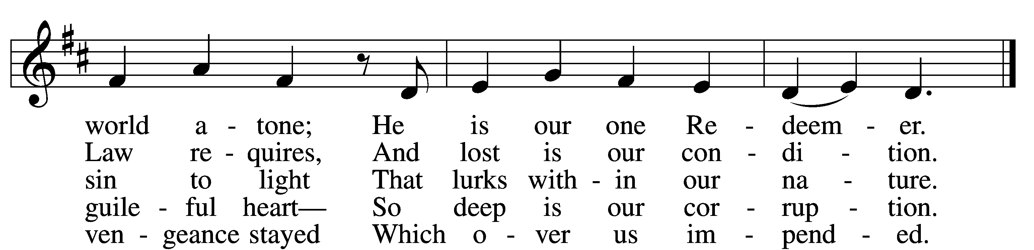
Sermon Pastor Grills
Reformation Reflection:
That we may obtain this faith, the Ministry of Teaching the Gospel and administering the Sacraments was instituted. For through the Word and Sacraments, as through instruments, the Holy Ghost is given, who works faith, where and when it pleases God, in them that hear the Gospel, to wit, that God, not for our own merits, but for Christ’s sake, justifies those who believe that they are received into grace for Christ’s sake.
Augsburg Confession, Article 5, “Of the Ministry”
555 Salvation unto Us Has Come, sts. 6–10 (choir sings st. 8)

6 Since Christ has full atonement made
And brought to us salvation,
Each Christian therefore may be glad
And build on this foundation.
Your grace alone, dear Lord, I plead,
Your death is now my life indeed,
For You have paid my ransom.
D
7 Let me not doubt, but truly see
Your Word cannot be broken;
Your call rings out, “Come unto Me!”
No falsehood have You spoken.
Baptized into Your precious name,
My faith cannot be put to shame,
And I shall never perish.

8 The Law reveals the guilt of sin
And makes us conscience-stricken;
But then the Gospel enters in
The sinful soul to quicken.
Come to the cross, trust Christ, and live;
The Law no peace can ever give,
No comfort and no blessing.
9 Faith clings to Jesus’ cross alone
And rests in Him unceasing;
And by its fruits true faith is known,
With love and hope increasing.
For faith alone can justify;
Works serve our neighbor and supply
The proof that faith is living.

10 All blessing, honor, thanks, and praise
To Father, Son, and Spirit,
The God who saved us by His grace;
All glory to His merit.
O triune God in heav’n above,
You have revealed Your saving love;
Your blessèd name we hallow.
Stand
Offertory LSB 192
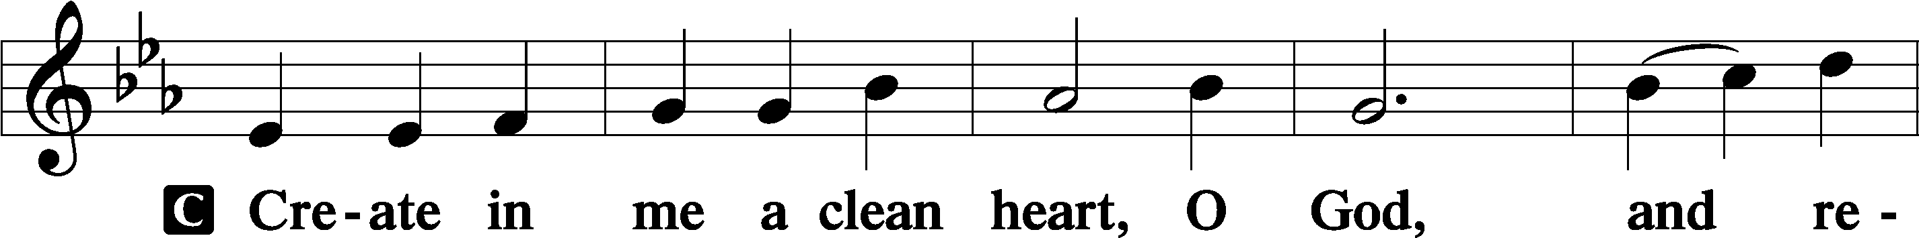
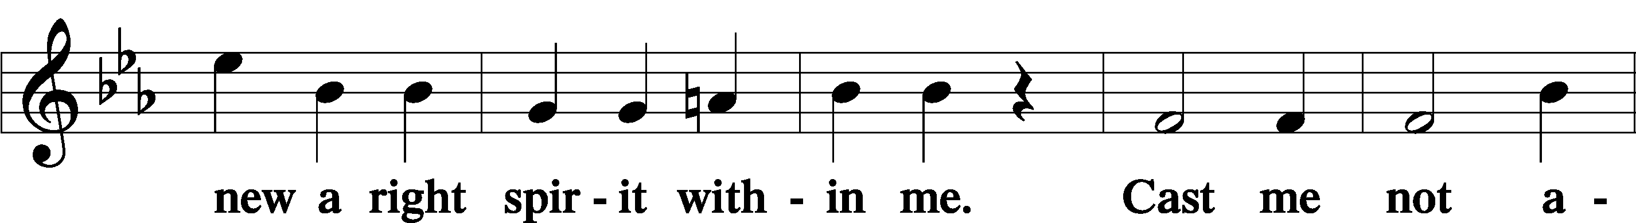
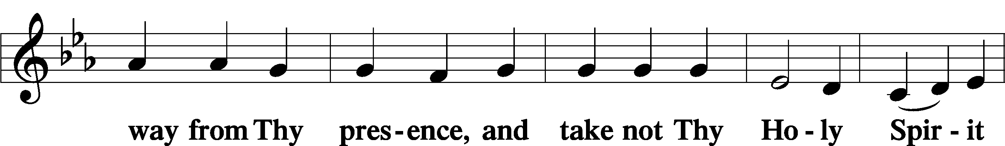
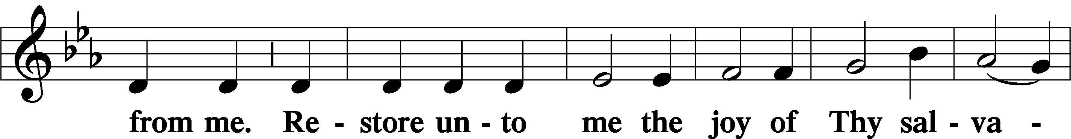
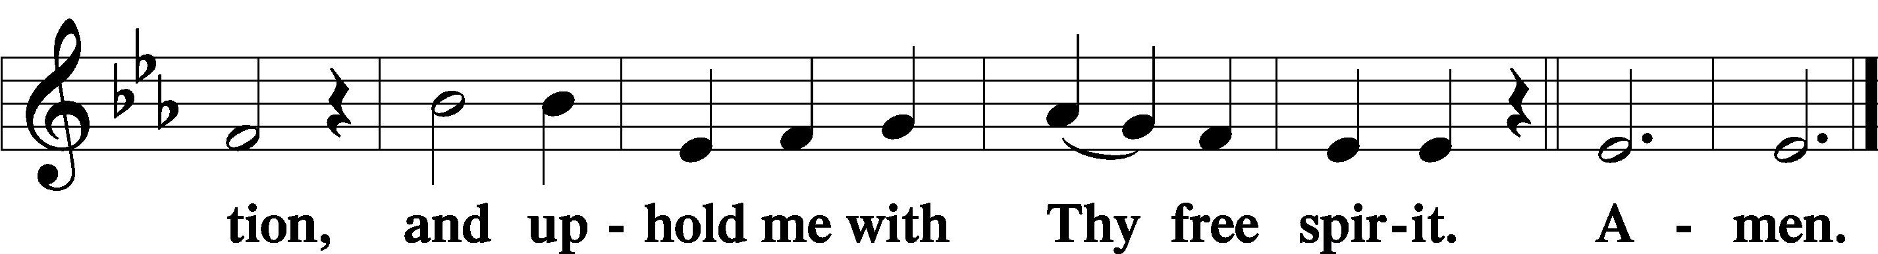
Prayer of the Church
Service of the Sacrament
Preface LSB 194
P The Lord be with you.
P Lift up your hearts.
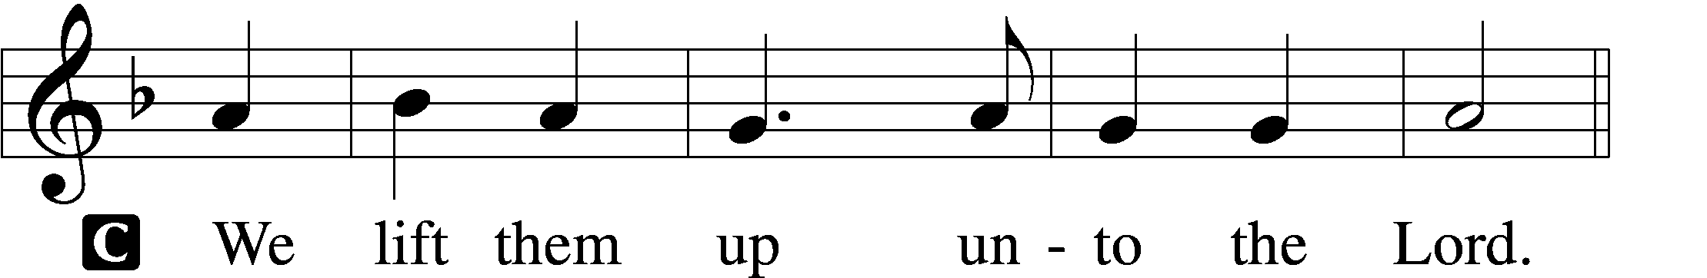
P Let us give thanks unto the Lord, our God.
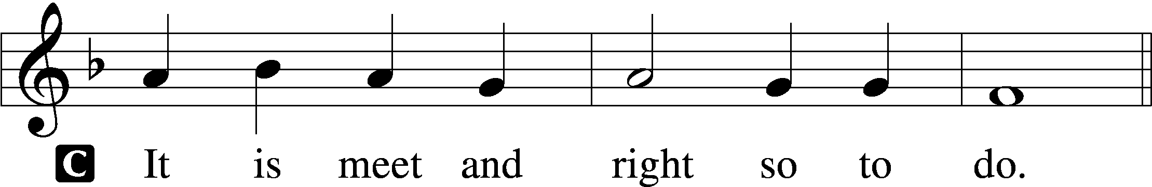

P It is truly meet, right, and salutary that we should at all times and in all places give thanks to You, holy Lord, almighty Father, everlasting God, who with Your only-begotten Son and the Holy Spirit are one God, one Lord. In the confession of the only true God, we worship the Trinity in person and the Unity in substance, of majesty coequal. Therefore with angels and archangels and with all the company of heaven we laud and magnify Your glorious name, evermore praising You and saying:
Sanctus LSB 195
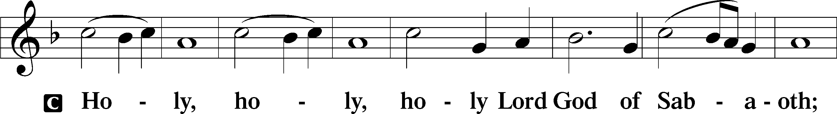
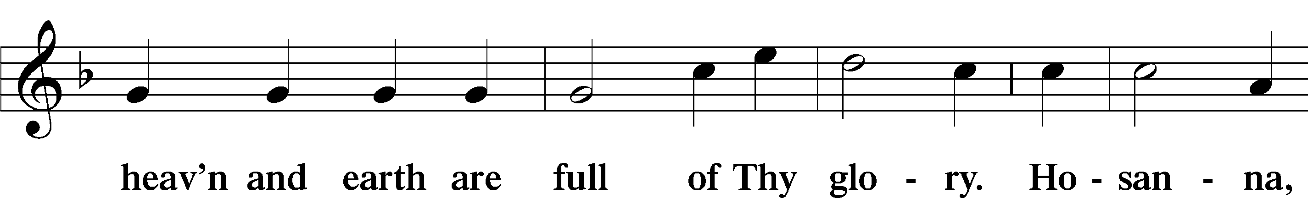
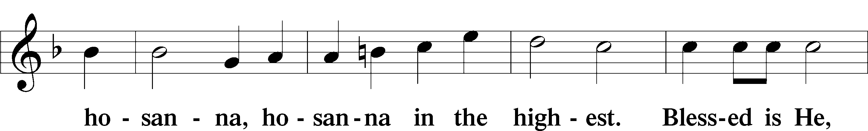
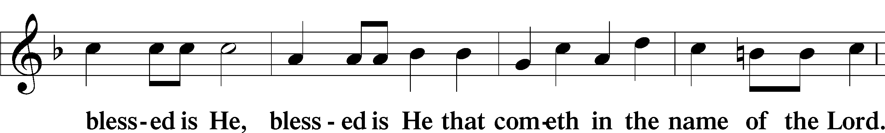
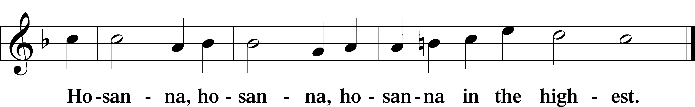
Lord’s Prayer LSB 196
P Lord, remember us in Your kingdom and teach us to pray:
C Our Father who art in heaven,
hallowed be Thy name,
Thy kingdom come,
Thy will be done on earth as it is in heaven;
give us this day our daily bread;
and forgive us our trespasses as we forgive those who trespass against us;
and lead us not into temptation,
but deliver us from evil.
For Thine is the kingdom and the power and the glory forever and ever. Amen.
The Words of Our Lord
Pax Domini LSB 197
P The peace of the Lord be with you always.
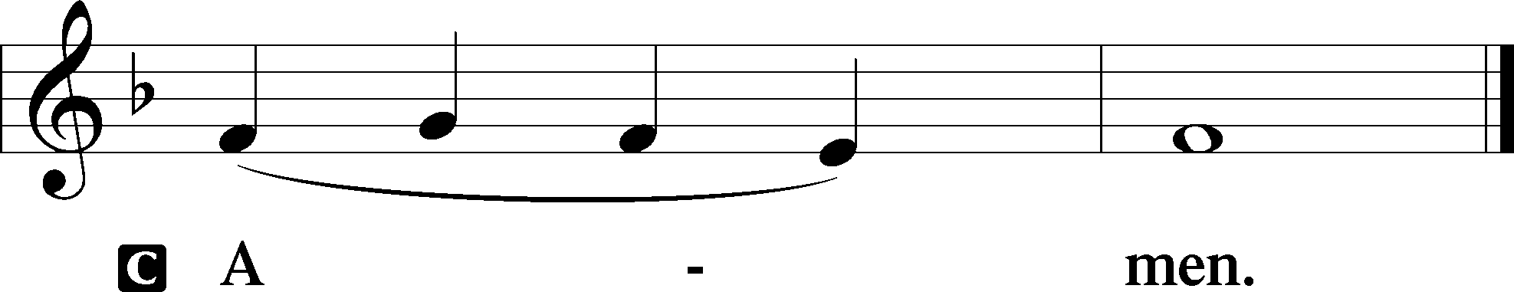
Agnus Dei LSB 198
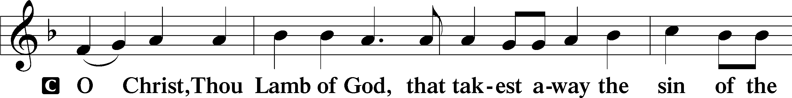
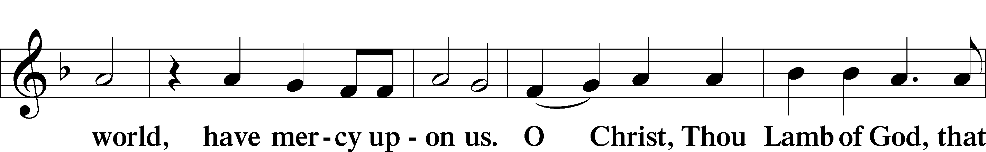
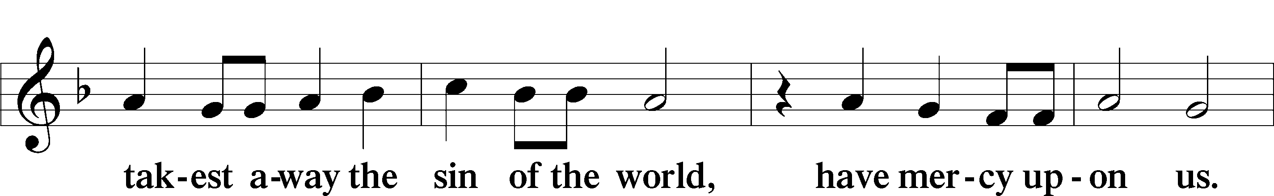
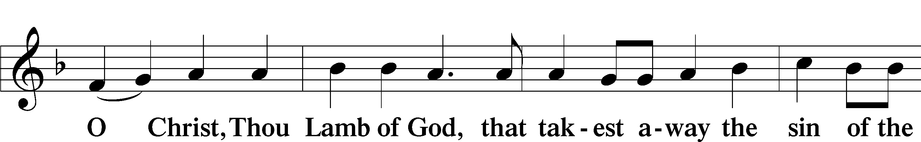
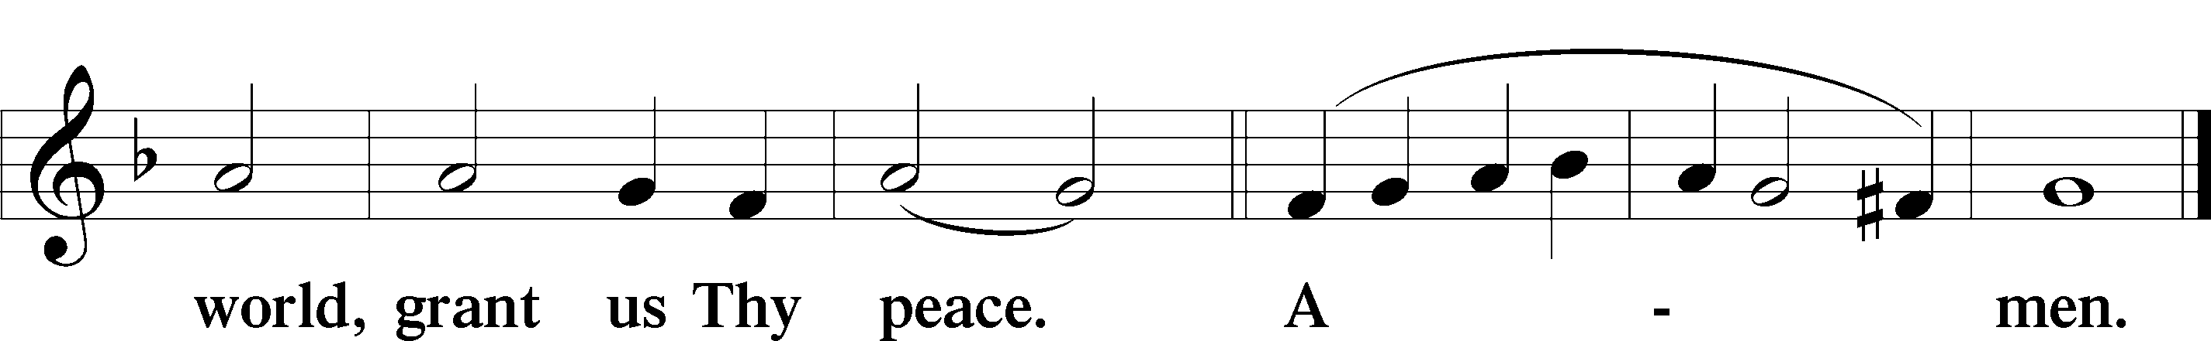
Sit
Distribution
Our Teaching on the Sacrament of Holy Communion
Attending communion at our altar indicates agreement with the doctrine and teachings of Scripture that our Lutheran Church Missouri Synod confesses. Therefore, only confirmed members of the Lutheran Church—Missouri Synod should come forward without first speaking to the pastor and being instructed. Thank you.
Prayer before communing
Dear Savior, at Your gracious invitation we come to Your table to eat and drink Your holy body and blood. Let us find favor in Your eyes to receive this holy Sacrament in faith for the salvation of our souls and to the glory of Your holy name; for You live and reign with the Father and the Holy Spirit, one God, now and forever.
Prayer after receiving the Sacrament
Almighty and everlasting God, we thank and praise You for feeding us the life-giving body and blood of Your beloved Son, Jesus Christ. Send us Your Holy Spirit that, having with our mouths received the holy Sacrament, we may by faith obtain and eternally enjoy Your divine grace, the forgiveness of sins, unity with Christ, and life eternal; through Jesus Christ, our Lord.
617 O Lord, We Praise Thee (choir sings st. 2; setting by J.S. Bach)
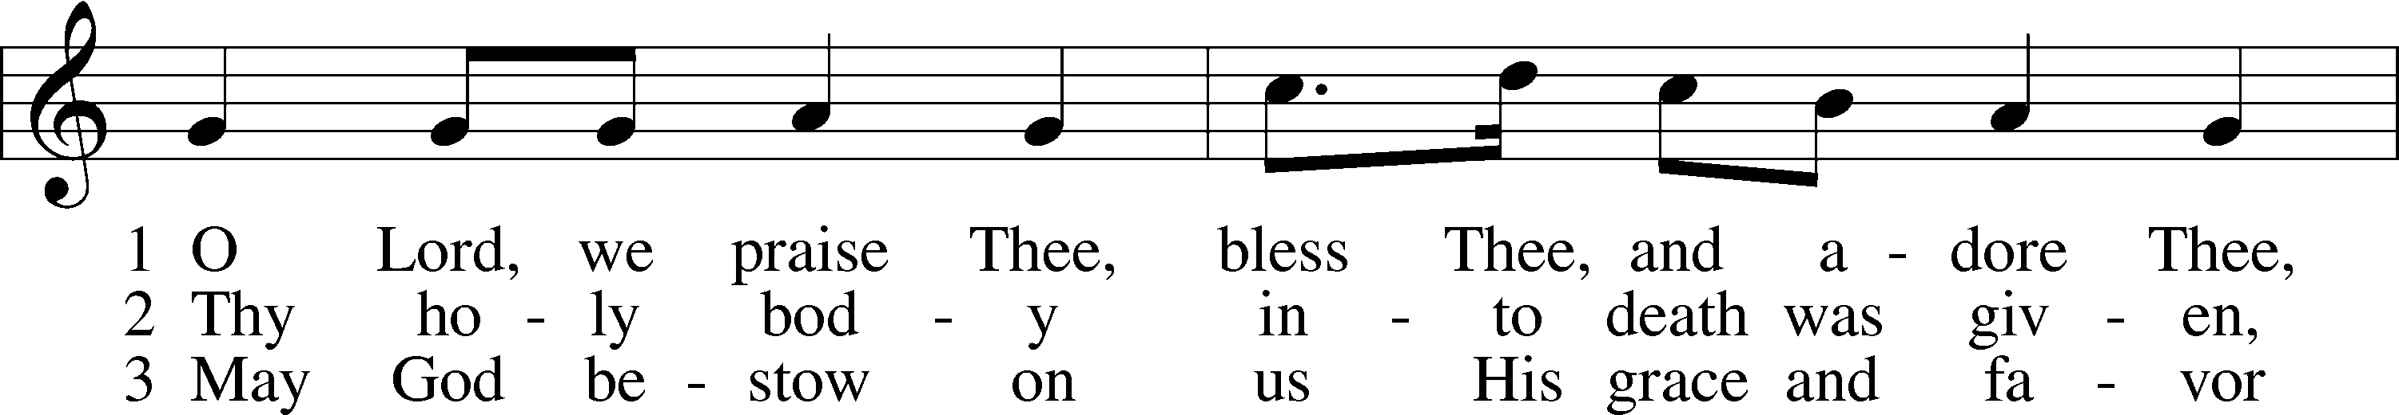
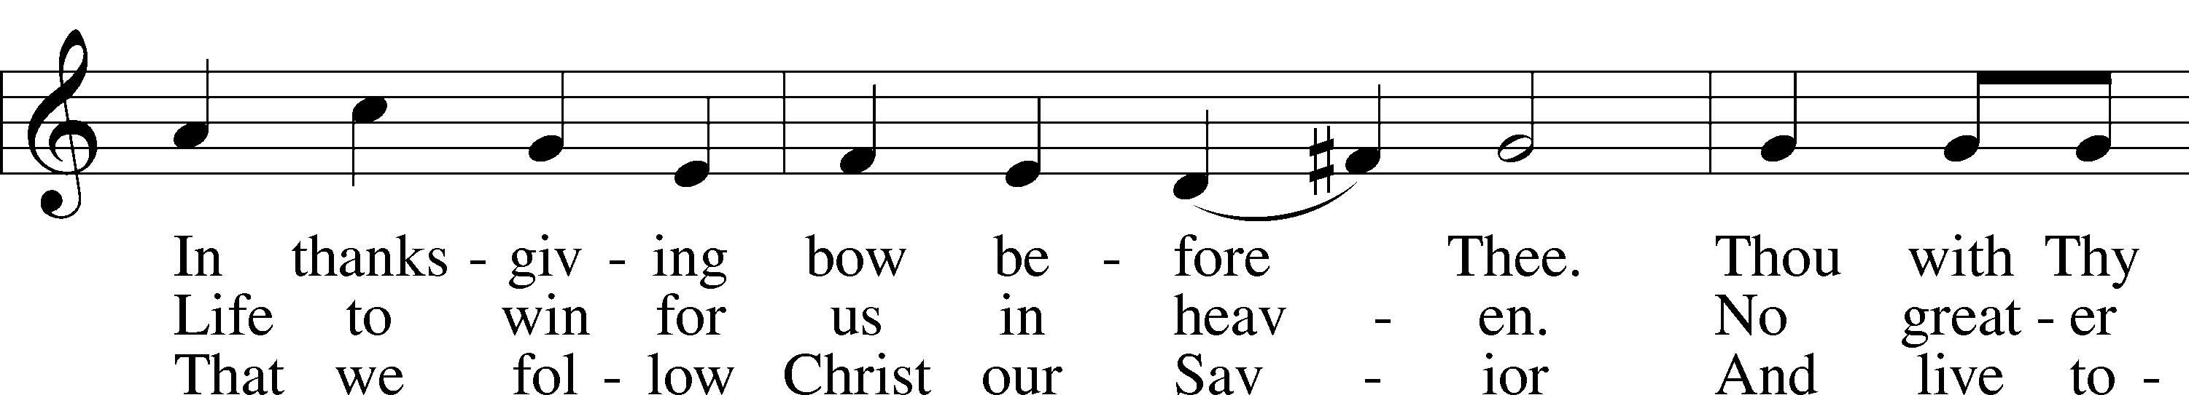
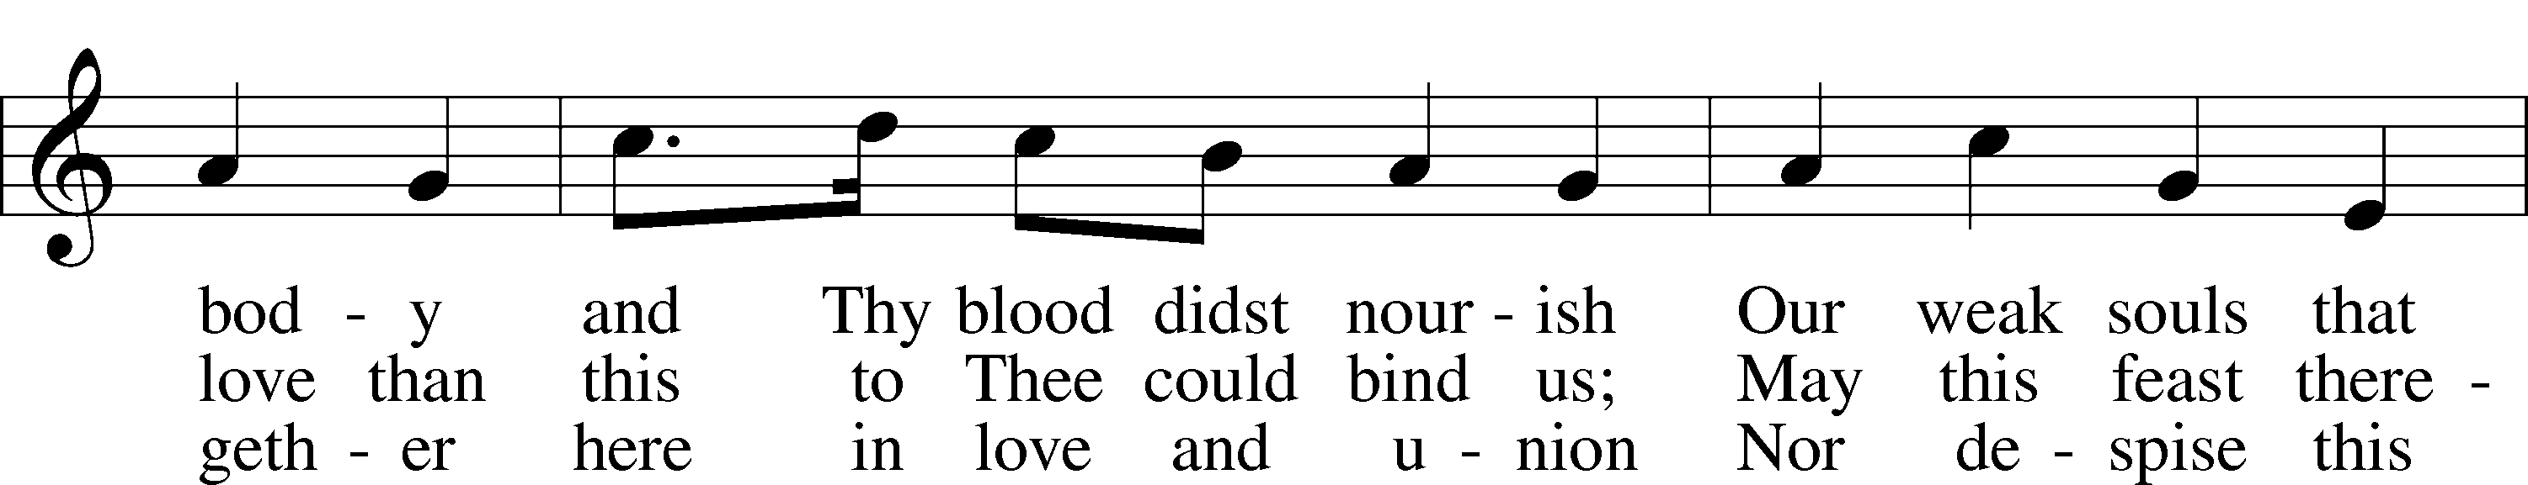
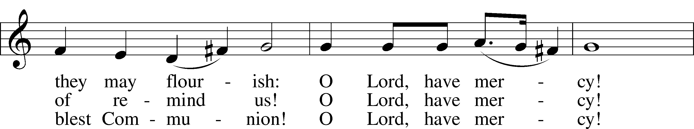
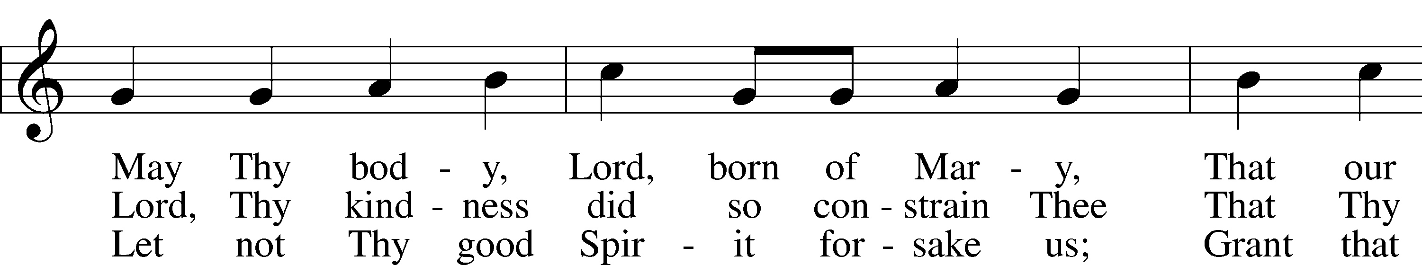
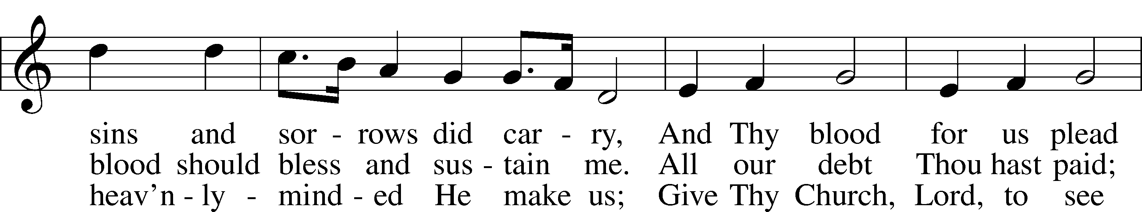
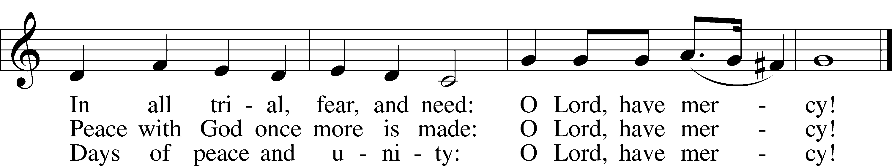
Choir: “Lord, Keep Us Steadfast in Your Word”
Text: Martin Luther; Setting: Jeremy J. Bankson

1 Lord, keep us steadfast in Your Word;
Curb those who by deceit or sword
Would wrest the kingdom from Your Son
And bring to naught all He has done.
2 Lord Jesus Christ, Your pow’r make known,
For You are Lord of lords alone;
Defend Your holy Church that we
May sing Your praise eternally.

3 O Comforter of priceless worth,
Send peace and unity on earth;
Support us in our final strife
And lead us out of death to life.
627 Jesus Christ, Our Blessed Savior
(stanzas sung as needed; organ interlude between sts. 6 & 7)
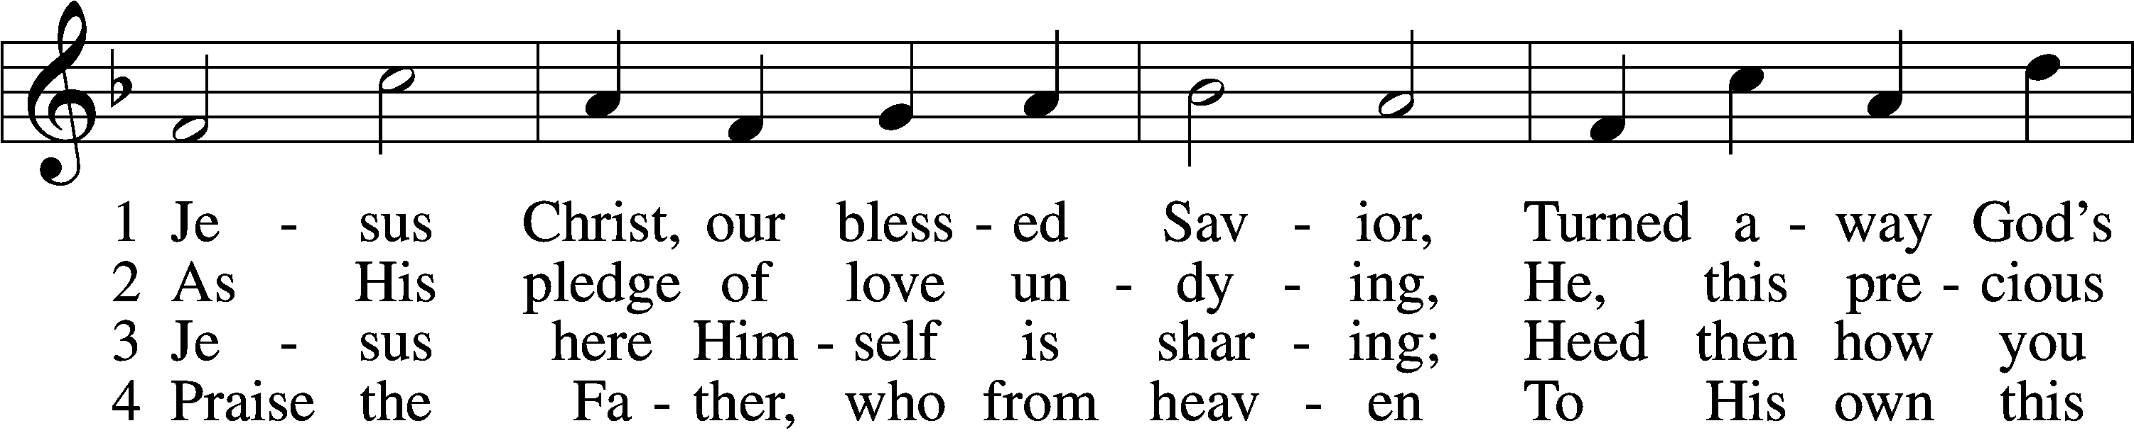
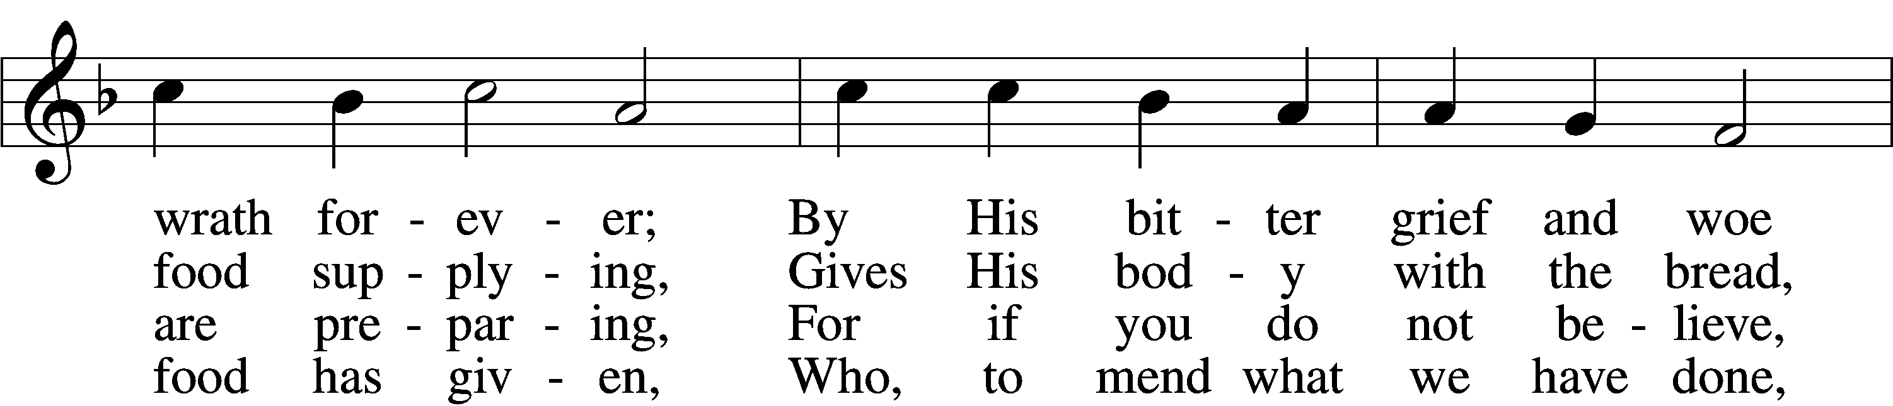
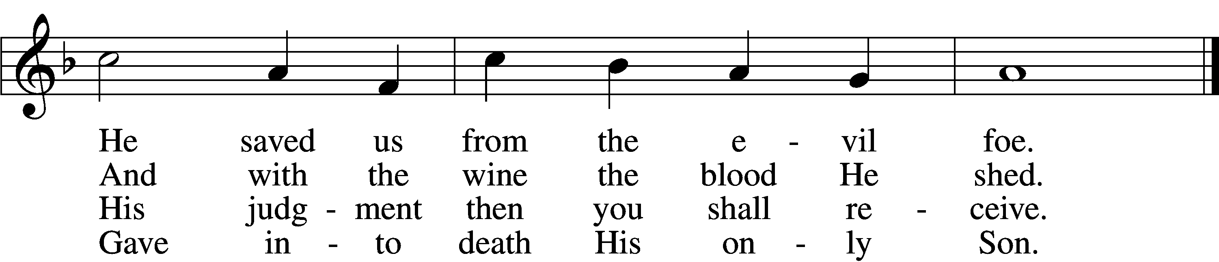

5 Firmly hold with faith unshaken
That this food is to be taken
By the sick who are distressed,
By hearts that long for peace and rest.

6 Agony and bitter labor
Were the cost of God’s high favor;
Do not come if you suppose
You need not Him who died and rose.
[organ interlude]
7 Christ says: “Come, all you that labor,
And receive My grace and favor:
Those who feel no pain or ill
Need no physician’s help or skill.
8 “For what purpose was My dying
If not for your justifying?
And what use this precious food
If you yourself were pure and good?”

9 If your heart this truth professes
And your mouth your sin confesses,
You will be your Savior’s guest,
Be at His banquet truly blest.
10 Let this food your faith so nourish
That its fruit of love may flourish
And your neighbor learn from you
How much God’s wondrous love can do.

Stand
The Dismissal LSB 199
P The body and blood of our Lord Jesus Christ strengthen and preserve you in body and soul to life everlasting. Depart T in peace.
C Amen.

Nunc Dimittis LSB 199
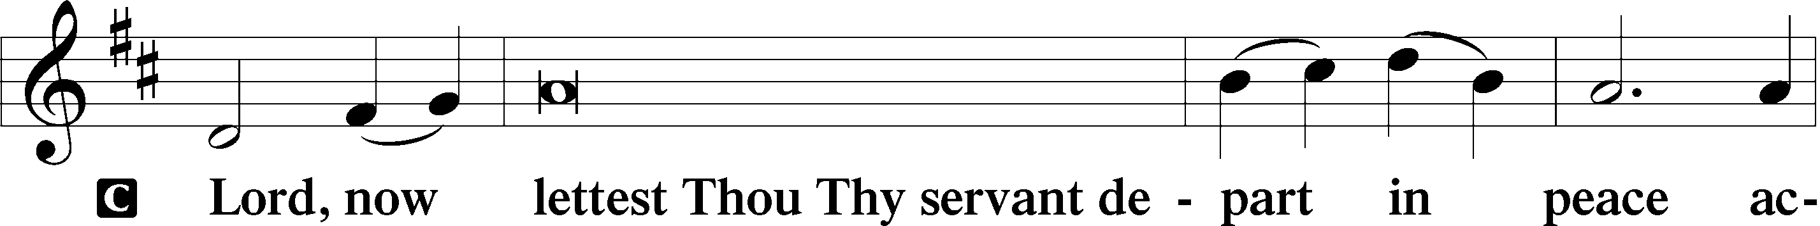
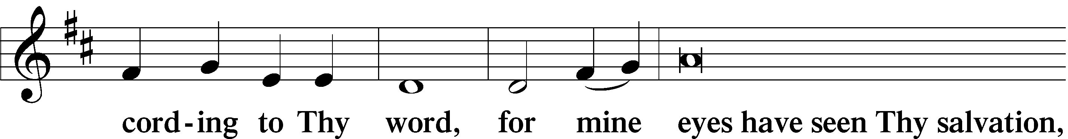
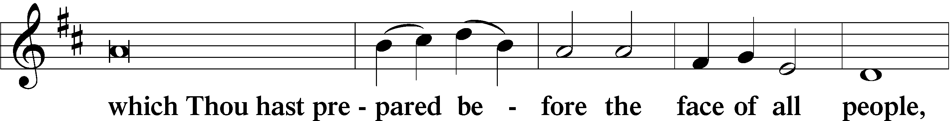
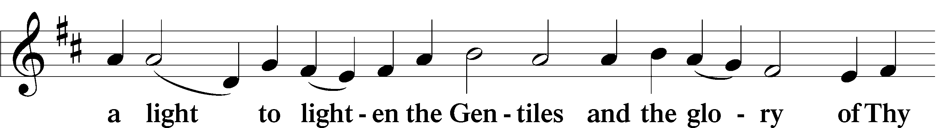
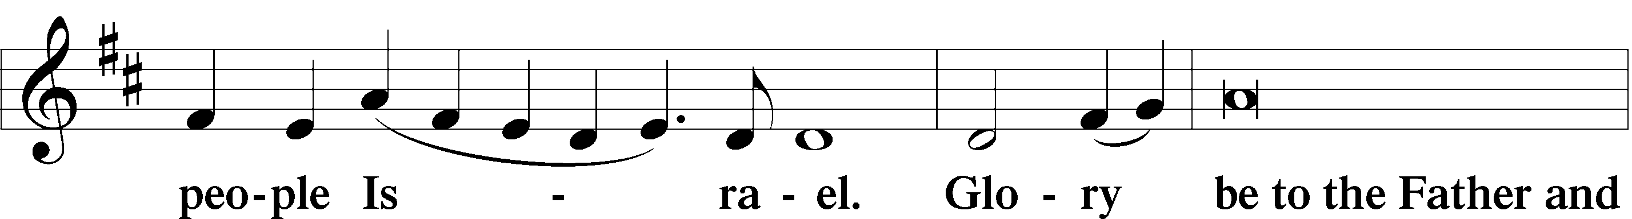
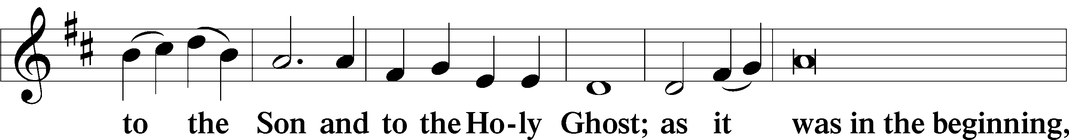
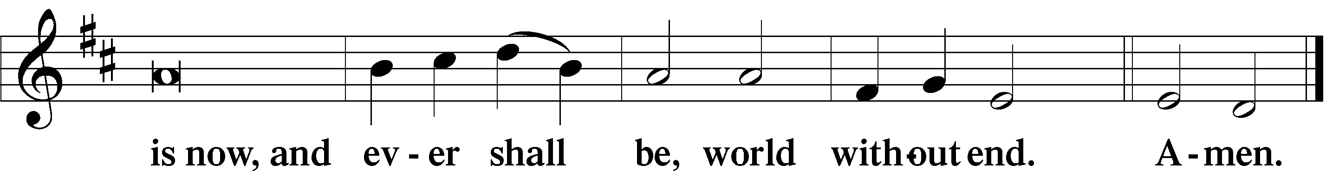
Reformation Reflection
“[Before the Reformation] the congregation had little part in the service. A great screen across the church shut them off. The priests did the business with God. The Reformation recovered Scripture’s truth that there are not higher and lower ranks in God’s family but that we are all brothers and sisters together before God our Father.
This fellowship is one of the greatest things expressed in our congregational singing. When we as a congregation sing to the Lord, we do not sing as individuals, but the voice of each of us is blended into the one voice of God’s family. . . . As our voices are taken up into the united voice of the church, we are a part of that body whose head is Christ. When we sing together, our fellowship is not only with all who worship in this church but also with the whole body of Christ that is not limited by place or time.
Norman Nagel, Selected Sermons of Norman Nagel, 226
Thanksgiving LSB 200
P O give thanks unto the Lord, for He is good,
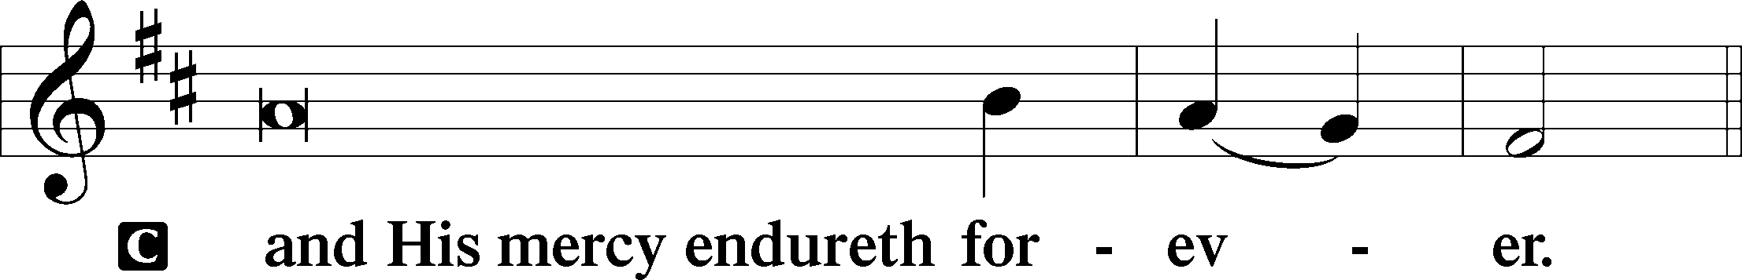
P Let us pray.
We give thanks to You, almighty God, that You have refreshed us through this salutary gift, and we implore You that of Your mercy You would strengthen us through the same in faith toward You and in fervent love toward one another; through Jesus Christ, Your Son, our Lord, who lives and reigns with You and the Holy Spirit, one God, now and forever.
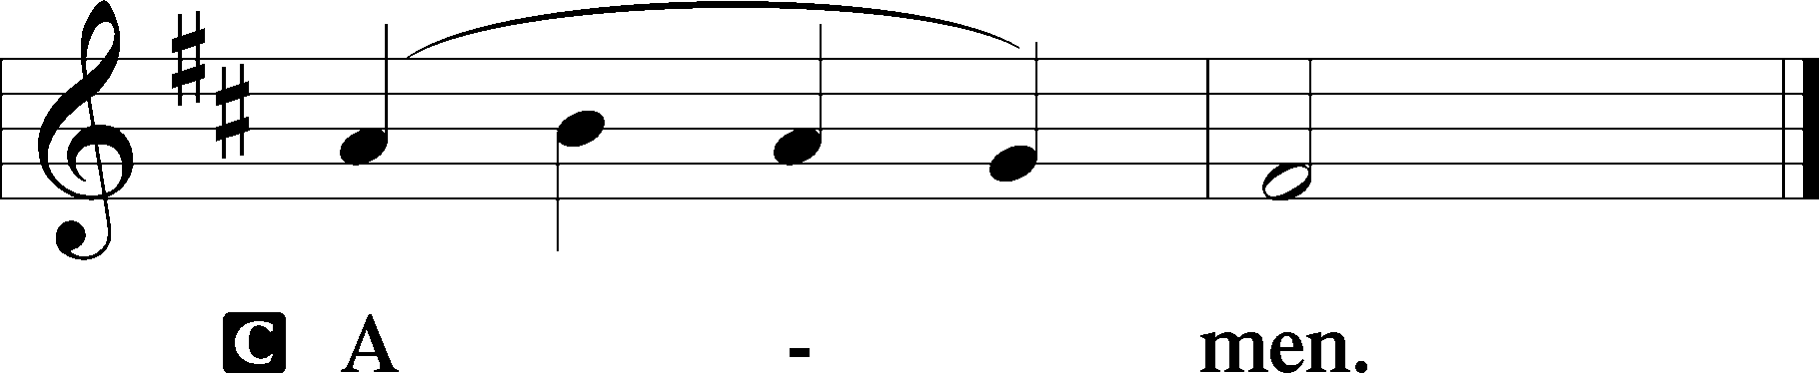
P The Lord be with you.
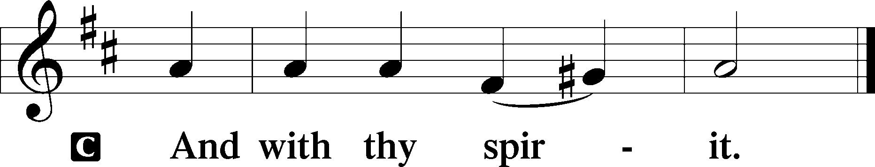
Benedicamus LSB 202
P Bless we the Lord.
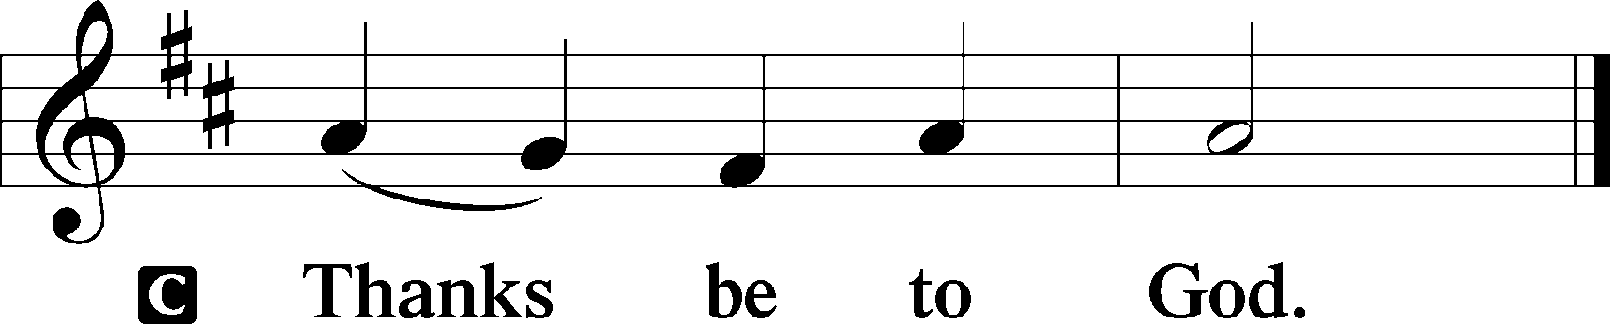
Benediction LSB 202
P The Lord bless you and keep you.
The Lord make His face shine upon you and be gracious unto you.
The Lord lift up His countenance upon you and T give you peace.
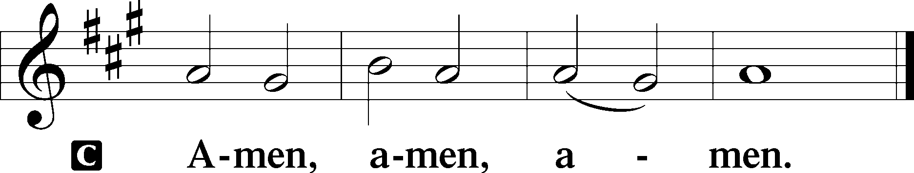
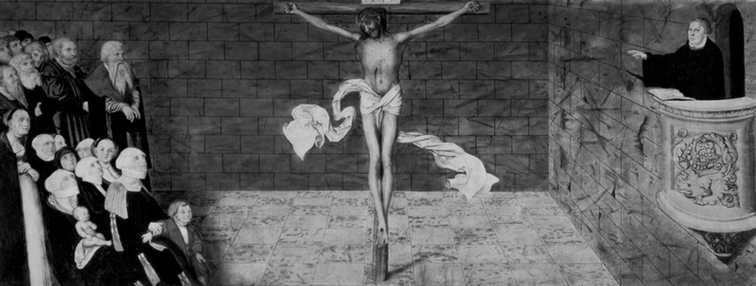
“Martin Luther Preaching” by Lucas Cranach the Elder, 1547.
Closing Hymn
578 Thy Strong Word
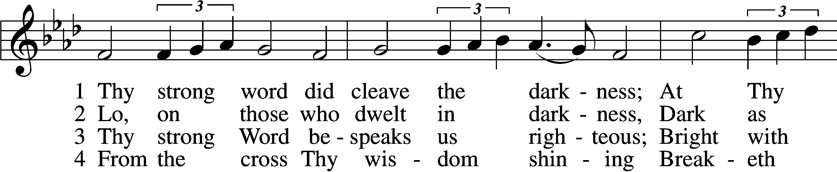
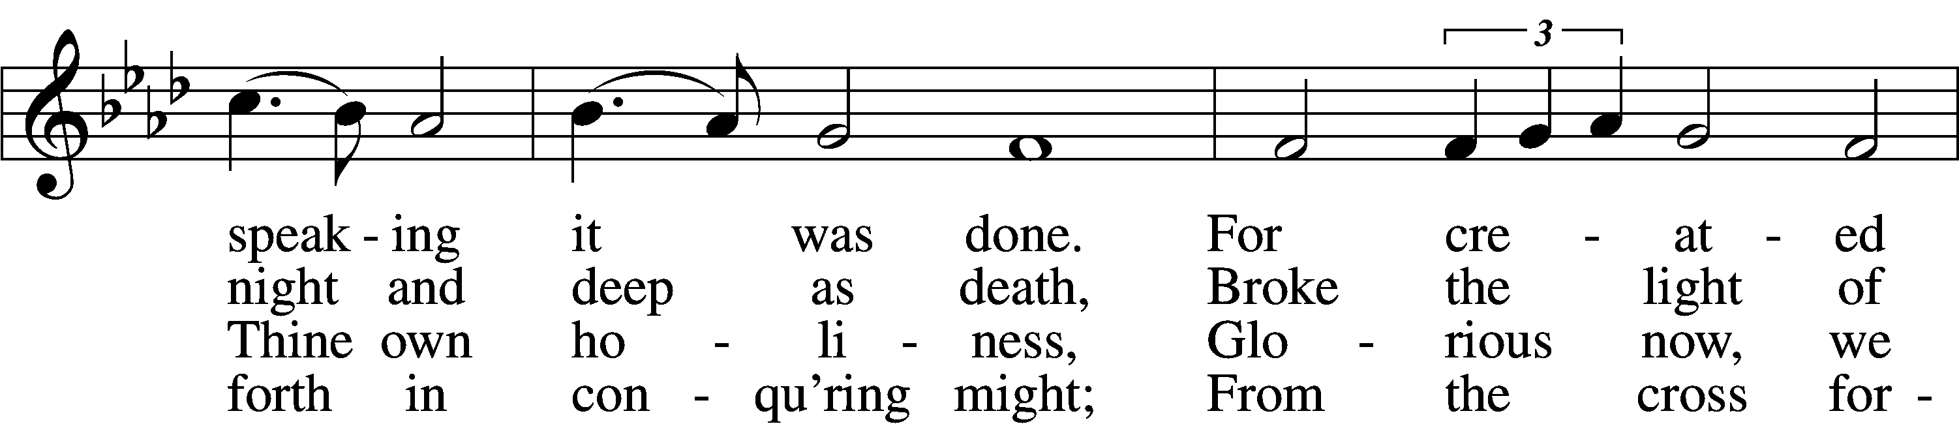
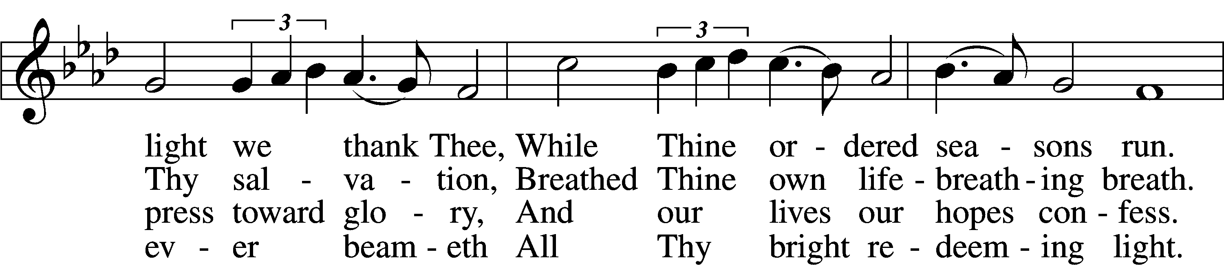
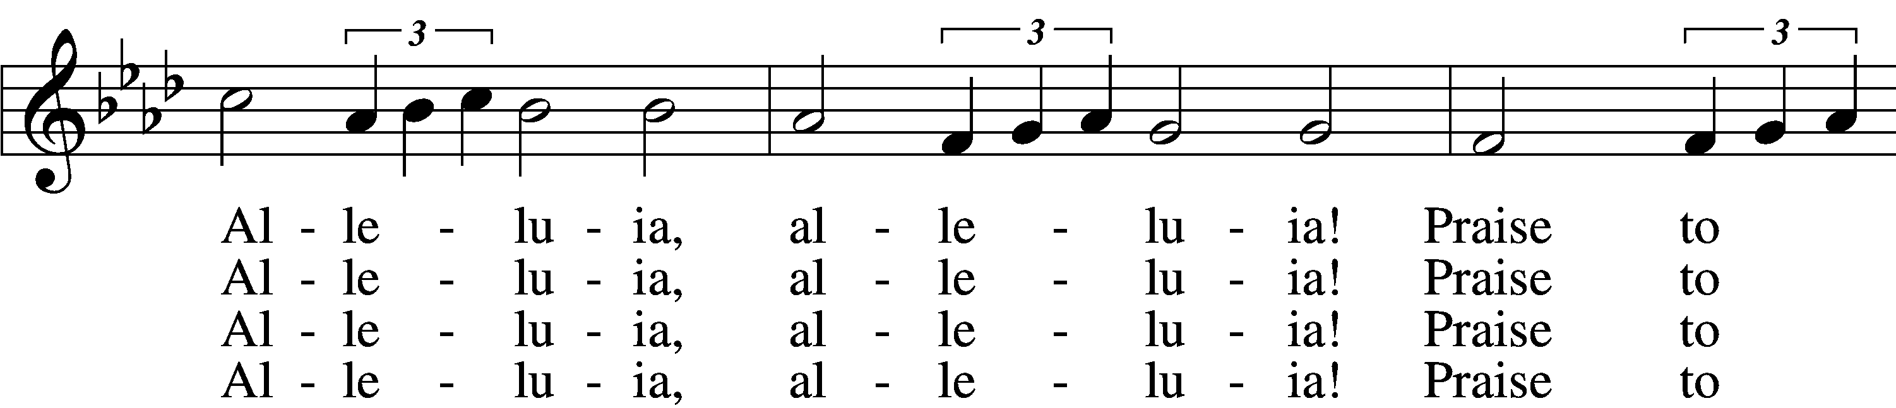
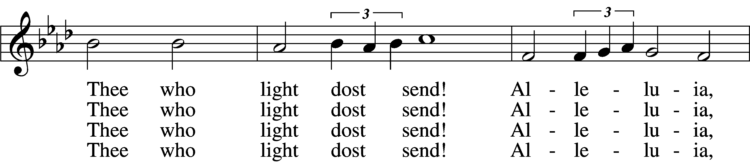
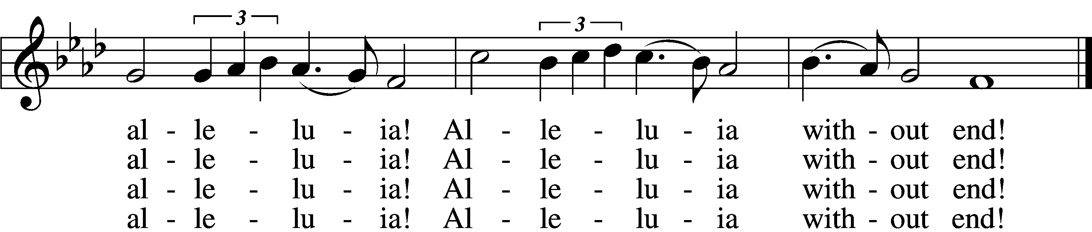

5 Give us lips to sing Thy glory,
Tongues Thy mercy to proclaim,
Throats that shout the hope that fills us,
Mouths to speak Thy holy name.
Alleluia, alleluia!
May the light which Thou dost send
Fill our songs with alleluias,
Alleluias without end!
D 6 God the Father, light-creator,
To Thee laud and honor be.
To Thee, Light of Light begotten,
Praise be sung eternally.
Holy Spirit, light-revealer,
Glory, glory be to Thee.
Mortals, angels, now and ever
Praise the holy Trinity!

Postlude
Brass Quintet Es ist das Heil uns kommen her arr. Scott Harris
(“Salvation unto Us Has Come”)
T
10/25 (Reformation) 11/1 (All Saints’ Day)
Celebrant/Preacher | Rev. Willie Grills | Rev. Willie Grills
Organist | Cantor Peter Eckardt | Cantor Peter Eckardt
Head Elder | Michael Martin
Assisting Elder | Scott Harris | Andy Adair
Altar Guild | Barbara Degler  Cindy Phipps | Christi Diepholz  Nancy Gass
Special Music | Adult Choir  Guest Brass Quintet:  Scott Harris, trumpet  Val Loomis, trumpet  Dave Fox, french horn  Michae Jewell, euphonium  Brian Loomis, trombone | Adult Choir  Marizza Shepard, flute
Prayer Requests
Contact the church office with prayer requests.
Those in Need of Comfort, Health, & Recovery:

Kim Henness
Mae Morris
Harvey Janssen
Melissa Wirth
Edith Creek
In the Military:
Kaitlyn Walker – US Navy
Brent Mauck – deployed in Kuwait
Dylan Haugh - US Marines
_____________________________________________________________________________________________________________________
Announcements
Altar Guild will meet Sat., October 31, 10:00-11:30am in the Fellowship Hall to review duties and plan for the upcoming Advent/Christmas season. If you’re interested in joining, contact Cantor Eckardt (peckardt@stjls-mattoon.com).
Adult Bible Class, led by an elder, and 8th-grade Confirmation Instruction, taught by Cantor Eckardt, will begin on Sunday mornings after church beginning November 1. The resumption of the remaining Sunday School classes is yet to be determined at this time.
Lutheran Annual: If you’d like a Lutheran Annual for your home, please contact the church office, and we can order you one. They are $27.99 plus shipping.
Pastor Grills has received a call to serve as pastor of St. John’s Evangelical Lutheran Church in Clarksburg, WV. Please keep him, his family, and all involved in your prayers as he deliberates this call.
Nominations: The following elected positions are open for nominations. President, Vice President, Secretary, Elders (4 positions), Trustees (1 position), Board of Christian Education (3 positions), Parish Life (3 positions), and Lay Member. Please contact Michael Gass 962-1008 if you are interested.
Upcoming Meetings: There will be a church council meeting on Monday, October 26 at 7:00 pm and Voters Assembly meeting on Monday, November 16 at 7:00 pm.
Papa Murphys’: Thank you to all who came out to support St. John’s School on our Papa Murphy’s night! We had our biggest Papa Murphy’s night yet and raised $497!
Rural King Church Week: Thank you to all who shopped at Rural King for Church Week. We received a check for $1,240!
Special Instructions and Notes in View of COVID-19
- One half of the sanctuary—the pulpit/organ side—is marked off every other pew, and masks are required. The other half of the sanctuary has all pews available, but you are encouraged to continue to space yourselves appropriately.
- Wearing a mask strongly is encouraged.
- Offerings will be collected as you enter or leave in the offering plates placed by the doors to the church itself.
- After the service, you will be ushered out to minimize the number of people in the narthex. Please proceed directly outside and to your vehicles.
- All other activities are canceled. There will be no Bible Study for the time being. Please use either the south sanctuary doors or the parking lot doors to enter and exit.
- Distribution of Communion will take place via a continuous line.
- Please observe a six-foot distance between family groups as you line up to receive, and follow the ushers’ directions to return to your seats. The ushers will direct you to the center aisle, where Pastor and an Elder will offer you Christ’s Body and Blood.
- Pastor and the Elder will wear masks during the Distribution. Their hands will be sanitized immediately before coming forward to serve you.
- Pastor will place the Body of Christ into your open hands. Please do not reach for the host to avoid any unnecessary touching. There will be fewer cups per tray to also minimize touching. Take care that you do not touch other cups as you take yours. There will be a tray nearby for you to place your cup in as you return to your seat.

Acknowledgments
Divine Service, Setting Three from Lutheran Service Book. Unless otherwise indicated, Scripture quotations are from the ESV® Bible (The Holy Bible, English Standard Version®), copyright © 2001 by Crossway, a publishing ministry of Good News Publishers. Used by permission. All rights reserved. Created by Lutheran Service Builder © 2018 Concordia Publishing House.
Today’s Music and Hymnody
A Mighty Fortress Is Our God is probably Lutheranism’s most popular hymn. Written and composed by Martin Luther, it’s knowns as “the battle hymn of the Reformation.” The original melody, which the congregation will sing for stanzas 1, 3, and 4 is rhythmic—note the strong martial beat accentuated by pick-up notes and syncopation. For stanza 2, the choir will sing an isorhythmic chorale setting by J.S. Bach, where the rhythm is simplified and evened out, allowing Bach’s brilliant harmonies to shine.

For the Introit, the choir sings Psalm 46 in its entirety to a 4-part setting based on the tune of A Mighty Fortress (Ein’ feste Burg). See if you can pick out the melody in the psalm chant.

The Hymn of the Day for Reformation is Salvation Unto Us Has Come by Paul Speratus and could be considered the “doctrinal hymn” of the Reformation. Written in 1523, its 10 stanzas (originally 14!) beautifully lay out the truths of our Lutheran-Christian faith: salvation by grace alone, faith alone, through Christ alone!

Luther is the author, in part, of all three Distribution Hymns. The first stanza of O Lord, We Praise Thee comes from the 14th century, but Luther composed stanzas 2 and 3. The melody is again quite rhythmic, and here too the choir sings an isorythmic Bach setting for stanza 2. Listen for those beautiful and unique harmonies that Bach is known for!

Dr. Luther’s Lord Keep Us Steadfast in Your Word was written as “a children’s hymn, to be sung against the two arch-enemies of Christ and His holy Church, the Pope and the Turk,” references to the Roman Catholic Church that was so hostile to the Reformation and the Islamic Turkish army that was threatening all of Christendom in Europe. The musical setting you will hear today is a 2017 composition by Jeremy Bankson for organ, trumpet, and choir.

For our Closing Hymn, we turn to the 20th century. The text of Thy Strong Word is written by erstwhile LCMS professor and theologian Martin Franzmann (1907–76), the tune (Ebenezer) by Welshman Thomas Williams (1869–1944), while the brass fanfare introduction and some of the organ accompaniment you’ll hear today is composed by noted Lutheran musician Carl Schalk (b. 1929).

We’re blessed this morning with the addition of a brass quintet to make our Reformation celebration all the more festive. You’ll hear two trumpets, a french horn, euphonium, and trombone this morning. Three of the musicians have come all the way from Indiana to play for our service, and our own Scott Harris composed some of the music you’ll hear them play this morning—the prelude, an arrangement on Ein’ Feste Burg (A Mighty Fortress) and the postlude, an arragment on Es ist das Heil (Salvation Unto Us Has Come).

~ Cantor Peter Eckardt

