The Transfiguration of Our Lord

Sunday, January 24, 2021, 8:00AM

Divine Service: LSB Setting II

St. John’s

Lutheran Church and School

200 Charleston Avenue Mattoon, Illinois 61938-4428

Church (217) 234-4923 School (217) 234-4911 Fax (217) 234-4925

www.stjohns-mattoon.org

Prelude
Opening Hymn
538 Praise Be to Christ
Please stand for the final stanza.
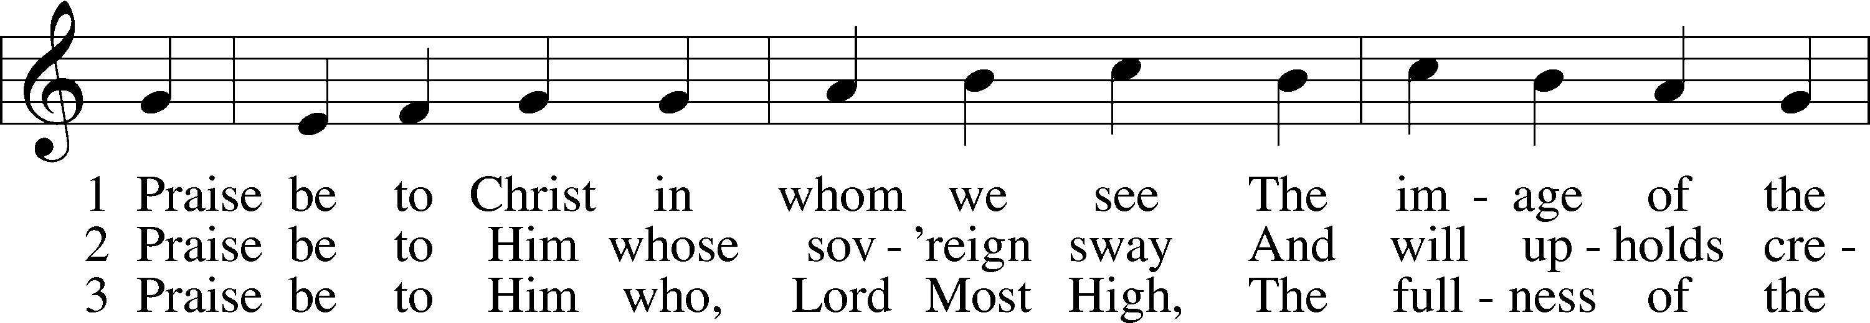
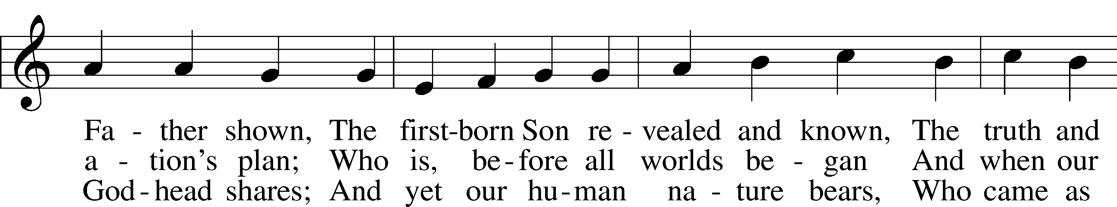
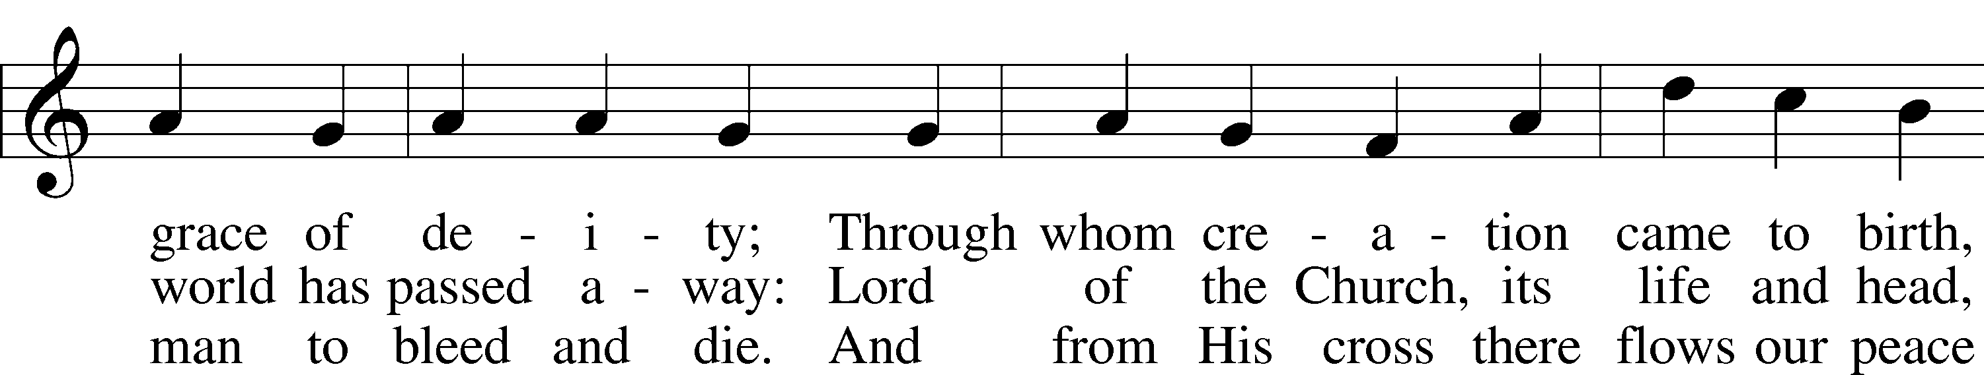
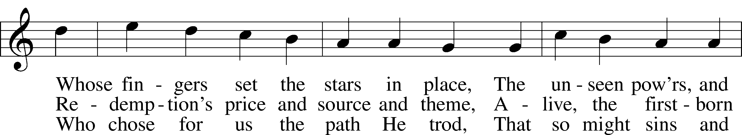
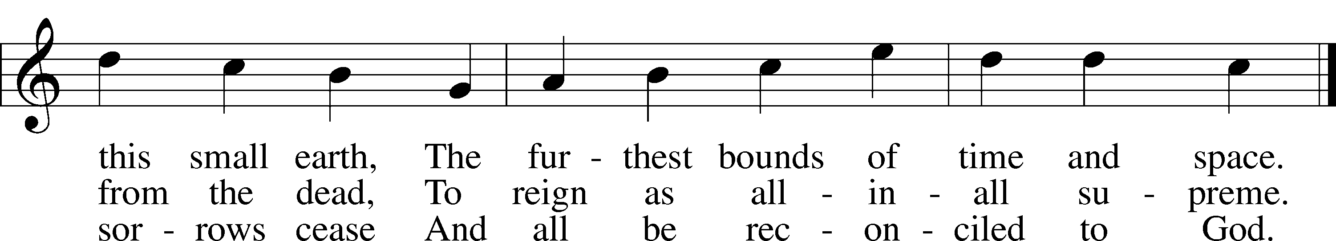

Text: © 1984 Hope Publishing Co. Used by permission: LSB Hymn License no. 110001348
Tune: Public domain
T
Confession and Absolution
The sign of the cross T may be made by all in remembrance of their Baptism.
P In the name of the Father and of the T Son and of the Holy Spirit.
C Amen.
P If we say we have no sin, we deceive ourselves, and the truth is not in us.
C But if we confess our sins, God, who is faithful and just, will forgive our sins and cleanse us from all unrighteousness.
Silence for reflection on God’s Word and for self-examination.
P Let us then confess our sins to God our Father.
C Most merciful God, we confess that we are by nature sinful and unclean. We have sinned against You in thought, word, and deed, by what we have done and by what we have left undone. We have not loved You with our whole heart; we have not loved our neighbors as ourselves. We justly deserve Your present and eternal punishment. For the sake of Your Son, Jesus Christ, have mercy on us. Forgive us, renew us, and lead us, so that we may delight in Your will and walk in Your ways to the glory of Your holy name. Amen.
P Almighty God in His mercy has given His Son to die for you and for His sake forgives you all your sins. As a called and ordained servant of Christ, and by His authority, I therefore forgive you all your sins in the name of the Father and of the T Son and of the Holy Spirit.
C Amen.
Service of the Word
Introit (sung by choir) Psalm 84:1–2a; antiphon: Ps. 77:18b (KJV)
The lightnings lightened the world: the earth trembled and shook.
How amiable are Thy tabernacles, O Lord of hosts!
My soul longeth, yea, even fainteth for the courts of the Lord.
Glory be to the Father and to the Son: and to the Holy Ghost;
As it was in the beginning, is now, and ever shall be: world without end. Amen.
The lightnings lightened the world: the earth trembled and shook.

Kyrie LSB 168
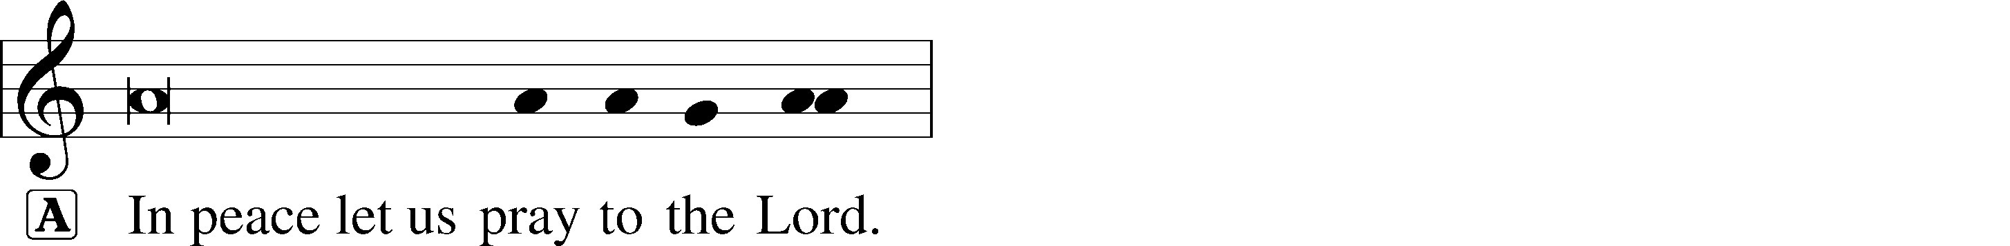
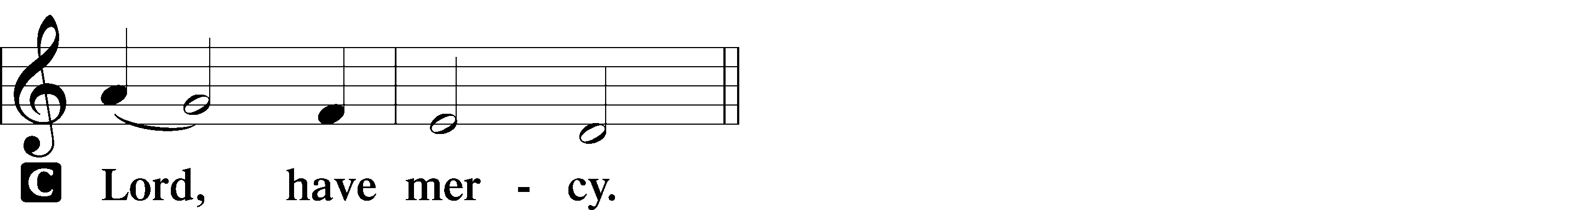
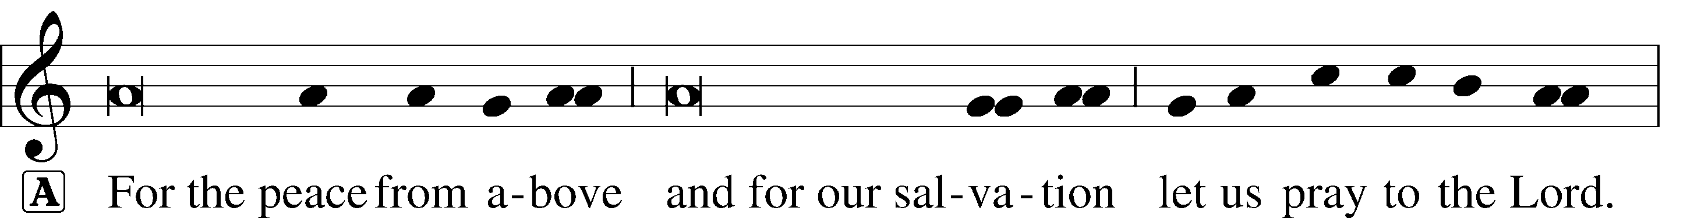
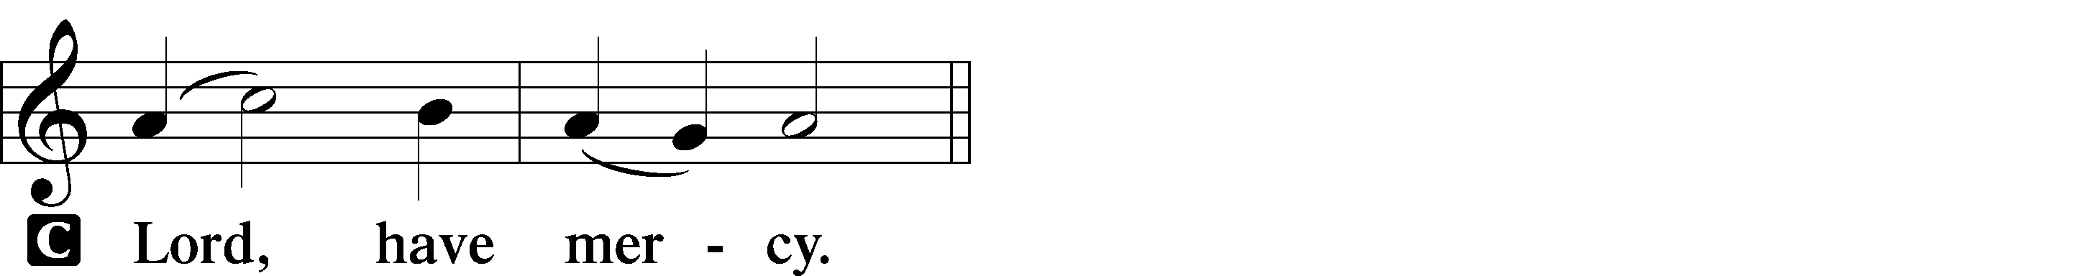

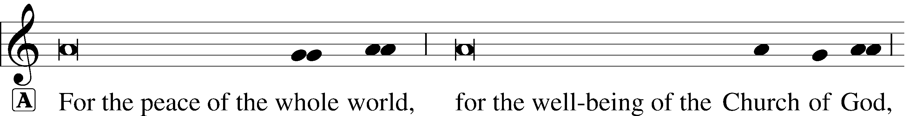
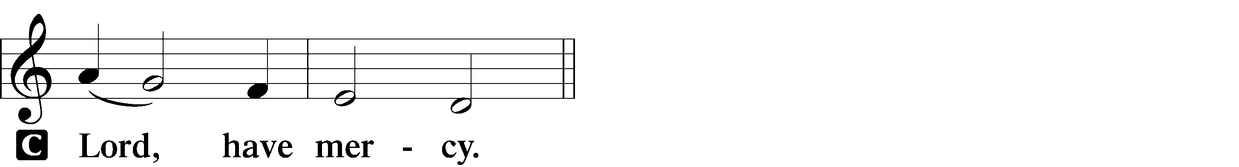

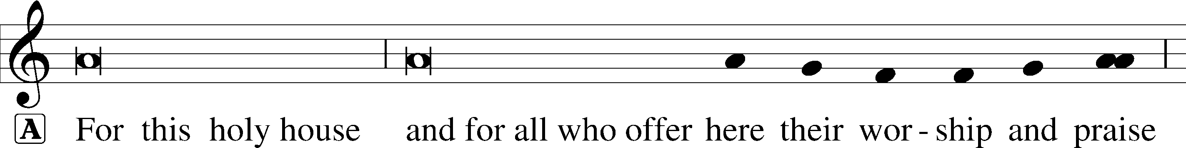
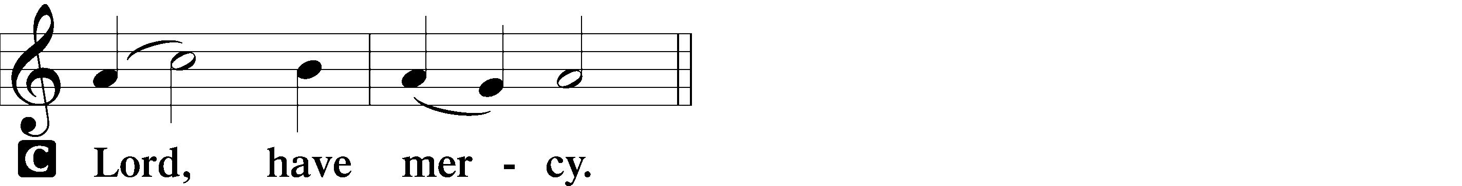

Gloria in Excelsis LSB 170
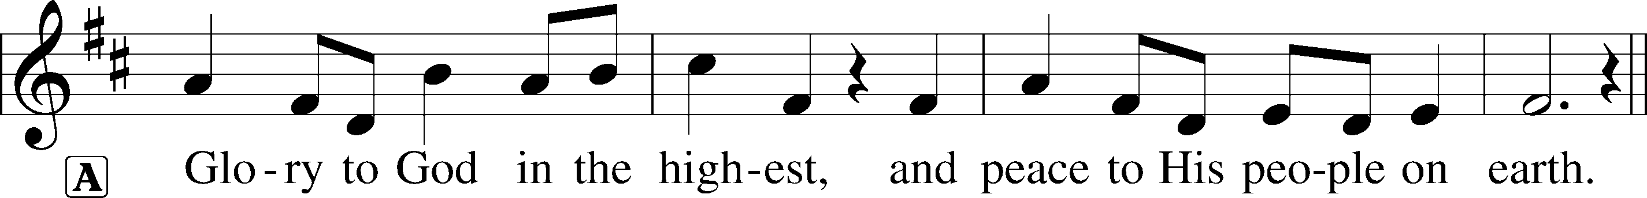
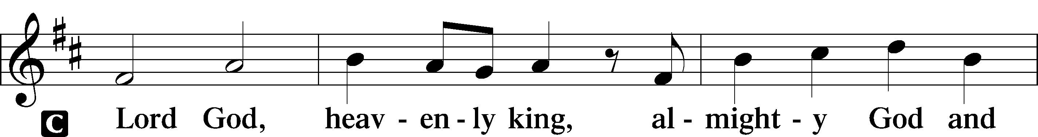
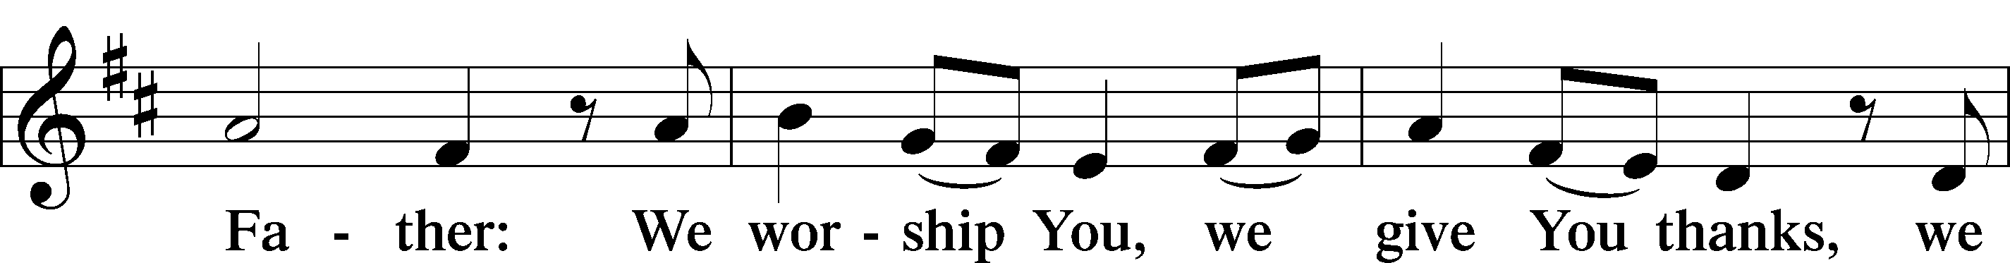
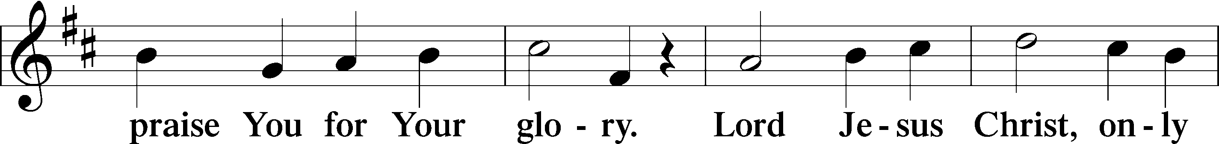
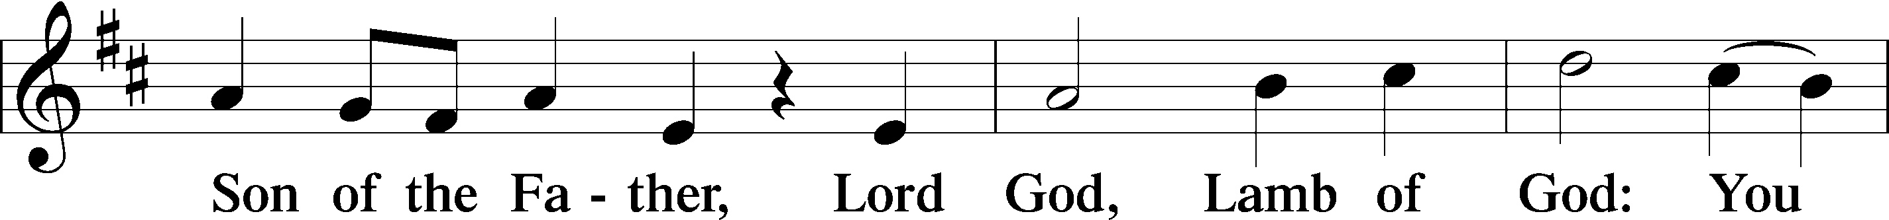
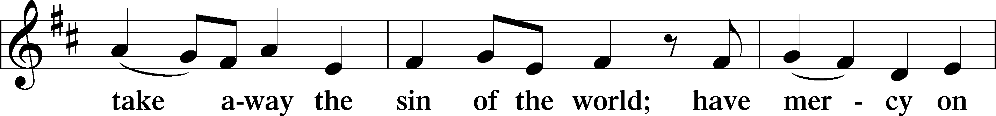
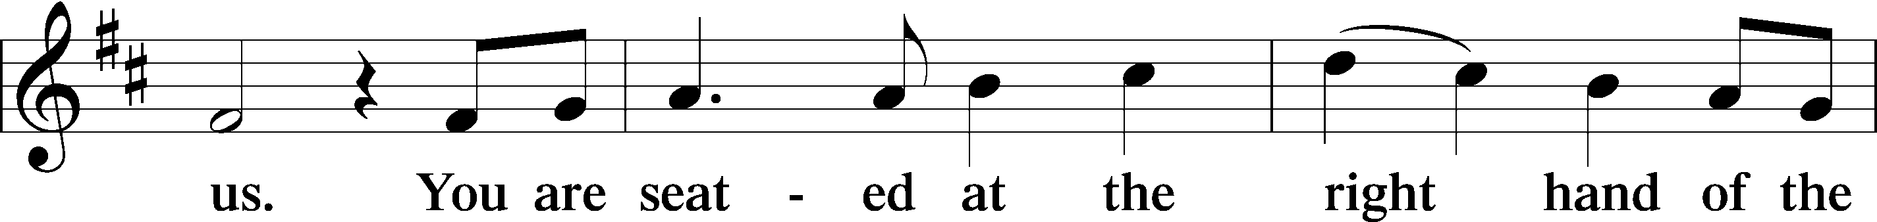
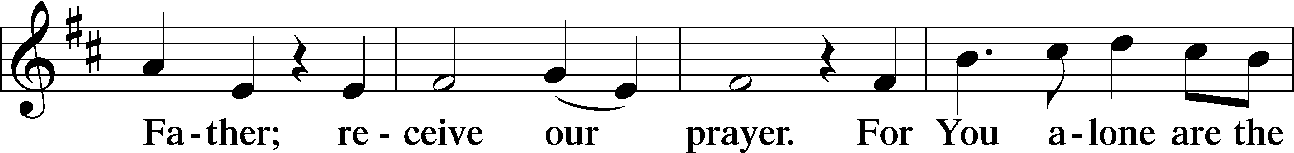
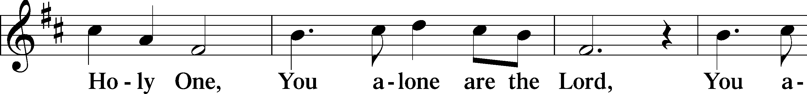
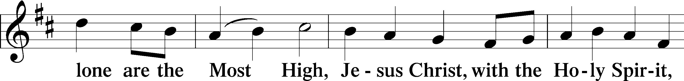
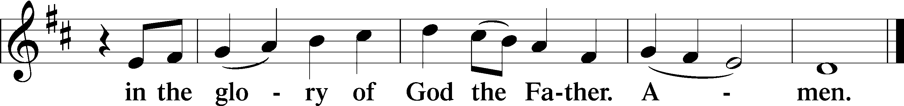
Salutation and Collect of the Day
P The Lord be with you.
C And with thy spirit.
P Let us pray.
O God, in the glorious transfiguration of Your beloved Son You confirmed the mysteries of the faith by the testimony of Moses and Elijah. In the voice that came from the bright cloud You wonderfully foreshowed our adoption by grace. Mercifully make us co-heirs with the King in His glory and bring us to the fullness of our inheritance in heaven; through the same Jesus Christ, our Lord, who lives and reigns with You and the Holy Spirit, one God, now and forever.
C Amen.
Sit
Old Testament Reading Exodus 34:29–35
²⁹When Moses came down from Mount Sinai, with the two tablets of the testimony in his hand as he came down from the mountain, Moses did not know that the skin of his face shone because he had been talking with God. ³⁰Aaron and all the people of Israel saw Moses, and behold, the skin of his face shone, and they were afraid to come near him. ³¹But Moses called to them, and Aaron and all the leaders of the congregation returned to him, and Moses talked with them. ³²Afterward all the people of Israel came near, and he commanded them all that the Lord had spoken with him in Mount Sinai. ³³And when Moses had finished speaking with them, he put a veil over his face.
³⁴Whenever Moses went in before the Lord to speak with him, he would remove the veil, until he came out. And when he came out and told the people of Israel what he was commanded, ³⁵the people of Israel would see the face of Moses, that the skin of Moses’ face was shining. And Moses would put the veil over his face again, until he went in to speak with him.
P This is the Word of the Lord.
C Thanks be to God.
Gradual (sung by choir) Psalm 45:2a; 110:1, 96:1–2 (KJV)
Thou art fairer than the children of men: grace is poured into thy lips.
The Lord said unto my Lord, Sit thou at my right hand, until I make thine enemies thy footstool. Alleluia! Alleluia!
Sing unto the Lord, bless his name; shew forth his salvation from day to day.
Declare his glory among the heathen, his wonders among all people. Alleluia!
Epistle 2 Peter 1:16–21
¹⁶For we did not follow cleverly devised myths when we made known to you the power and coming of our Lord Jesus Christ, but we were eyewitnesses of his majesty. ¹⁷For when he received honor and glory from God the Father, and the voice was borne to him by the Majestic Glory, “This is my beloved Son, with whom I am well pleased,” ¹⁸we ourselves heard this very voice borne from heaven, for we were with him on the holy mountain. ¹⁹And we have something more sure, the prophetic word, to which you will do well to pay attention as to a lamp shining in a dark place, until the day dawns and the morning star rises in your hearts, ²⁰knowing this first of all, that no prophecy of Scripture comes from someone’s own interpretation. ²¹For no prophecy was ever produced by the will of man, but men spoke from God as they were carried along by the Holy Spirit.
P This is the Word of the Lord.
C Thanks be to God.

Stand
Alleluia and Verse LSB 173
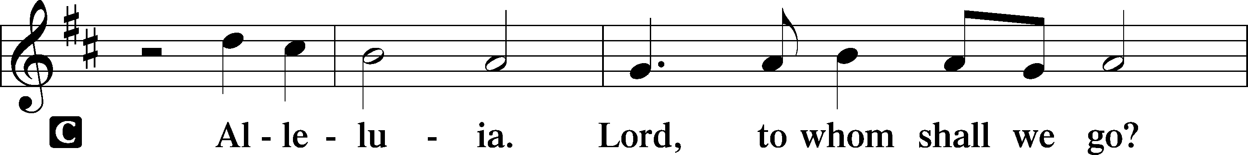
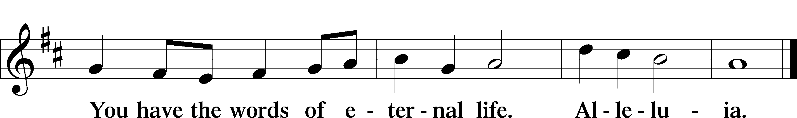
Holy Gospel Matthew 17:1–9
P The Holy Gospel according to St. Matthew, the seventeenth chapter.
C Glory be to Thee, O Lord.
¹After six days Jesus took with him Peter and James, and John his brother, and led them up a high mountain by themselves. ²And he was transfigured before them, and his face shone like the sun, and his clothes became white as light. ³And behold, there appeared to them Moses and Elijah, talking with him. ⁴And Peter said to Jesus, “Lord, it is good that we are here. If you wish, I will make three tents here, one for you and one for Moses and one for Elijah.” ⁵He was still speaking when, behold, a bright cloud overshadowed them, and a voice from the cloud said, “This is my beloved Son, with whom I am well pleased; listen to him.” ⁶When the disciples heard this, they fell on their faces and were terrified. ⁷But Jesus came and touched them, saying, “Rise, and have no fear.” ⁸And when they lifted up their eyes, they saw no one but Jesus only.
⁹And as they were coming down the mountain, Jesus commanded them, “Tell no one the vision, until the Son of Man is raised from the dead.”
P This is the Gospel of the Lord.
C Praise to You, O Christ.
Apostles’ Creed
C I believe in God, the Father Almighty,
maker of heaven and earth.
And in Jesus Christ, His only Son, our Lord,
who was conceived by the Holy Spirit,
born of the virgin Mary,
suffered under Pontius Pilate,
was crucified, died and was buried.
He descended into hell.
The third day He rose again from the dead.
He ascended into heaven
and sits at the right hand of God the Father Almighty.
From thence He will come to judge the living and the dead.
I believe in the Holy Spirit,
the holy Christian Church,
the communion of saints,
the forgiveness of sins,
the resurrection of the body,
and the life T everlasting. Amen.

Sit
413 O Wondrous Type! O Vision Fair (choir sings stanzas 2 and 4)
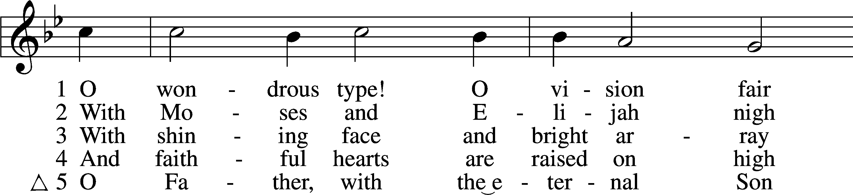
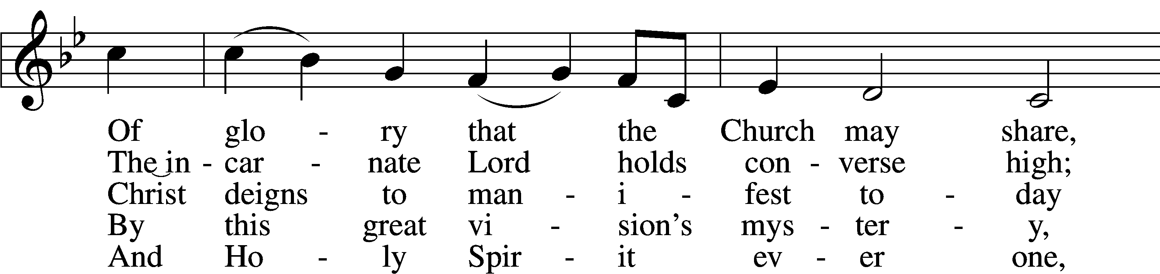
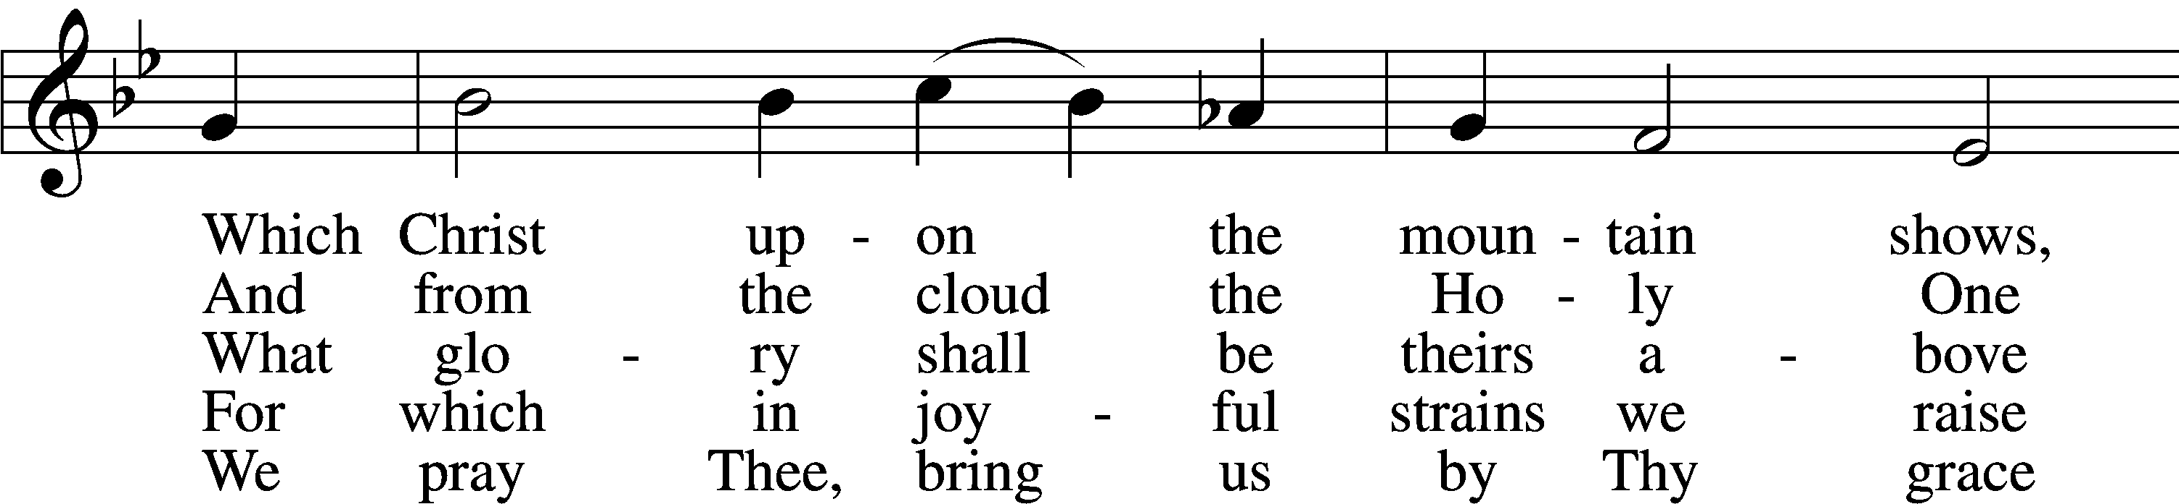
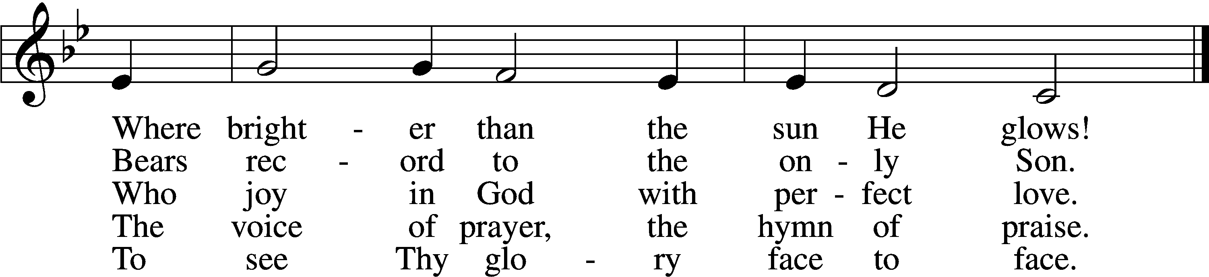
Choral setting by J.S. Bach, arr. by Peter Eckardt
Sermon Pastor Grills
Stand
Offertory LSB 176
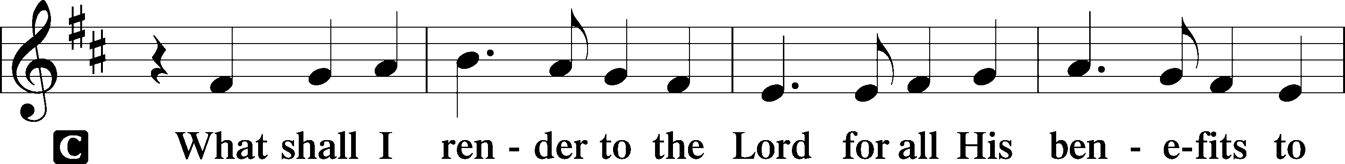
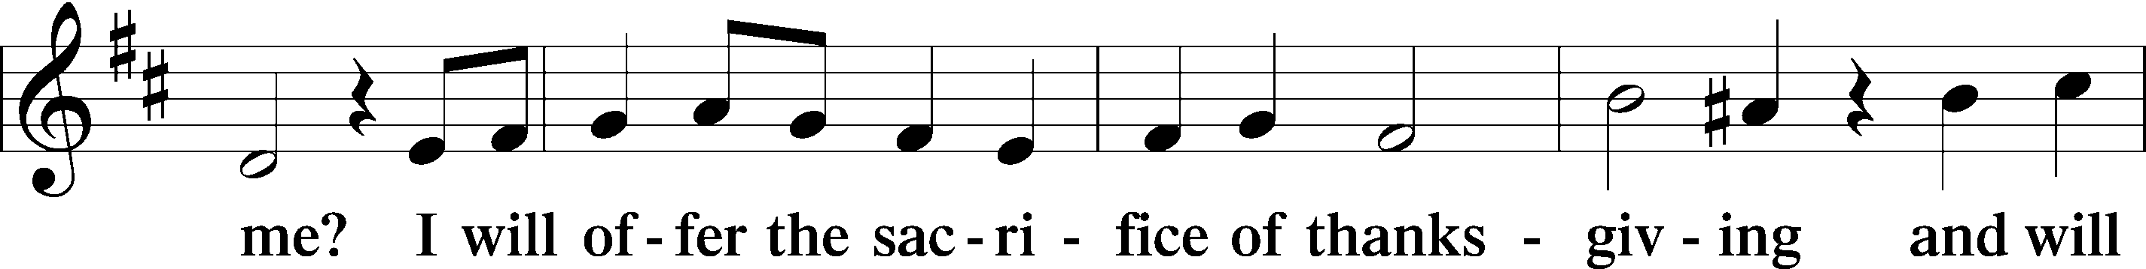
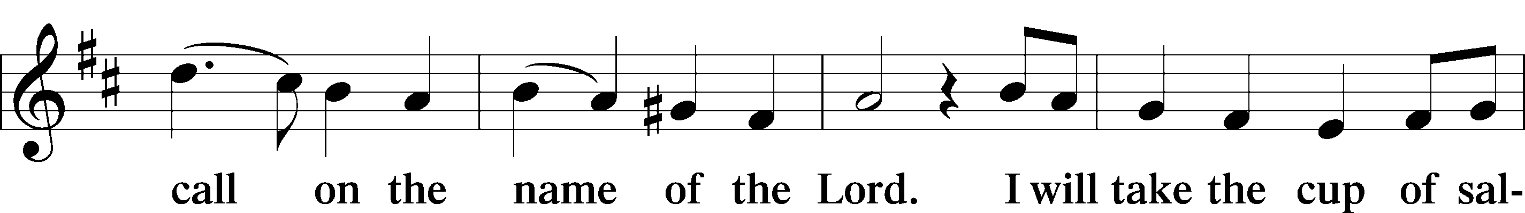
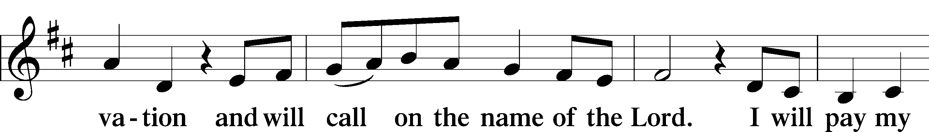
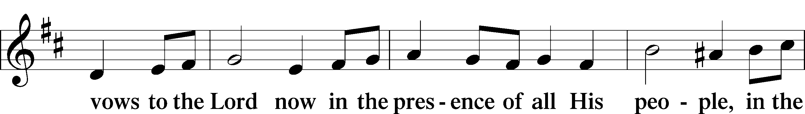
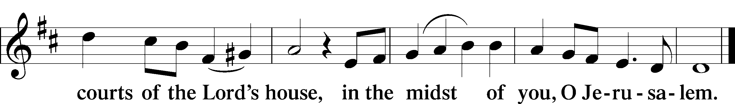
Prayer of the Church
Lord’s Prayer
P Lord, remember us in Your kingdom and teach us to pray:
C Our Father who art in heaven,
hallowed be Thy name,
Thy kingdom come,
Thy will be done on earth as it is in heaven;
give us this day our daily bread;
and forgive us our trespasses as we forgive those who trespass against us;
and lead us not into temptation,
but deliver us from evil.
For Thine is the kingdom and the power and the glory forever and ever. Amen.
Collect for the Word
P Blessed Lord, You have caused all Holy Scriptures to be written for our learning. Grant that we may so hear them, read, mark, learn, and take them to heart that, by the patience and comfort of Your holy Word, we may embrace and ever hold fast the blessed hope of everlasting life; through Jesus Christ, Your Son, our Lord, who lives and reigns with You and the Holy Spirit, one God, now and forever.
C Amen.
Luther’s Morning Prayer
C I thank You, my heavenly Father, through Jesus Christ, Your dear Son, that You have kept me this night from all harm and danger; and I pray that You would keep me this day also from sin and every evil, that all my doings and life may please You. For into Your hands I commend myself, my body and soul, and all things. Let Your holy angel be with me, that the evil foe may have no power over me. Amen.
Benediction
P The Lord bless thee and keep thee.
The Lord make His face shine upon thee and be gracious unto thee.
The Lord lift up His countenance upon thee and T give thee peace.
C Amen.
Closing Hymn
417 Alleluia, Song of Gladness
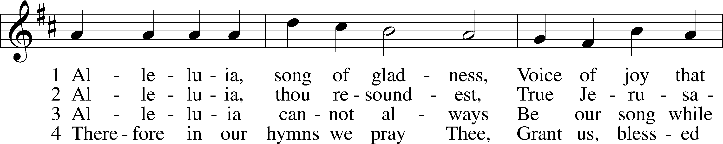
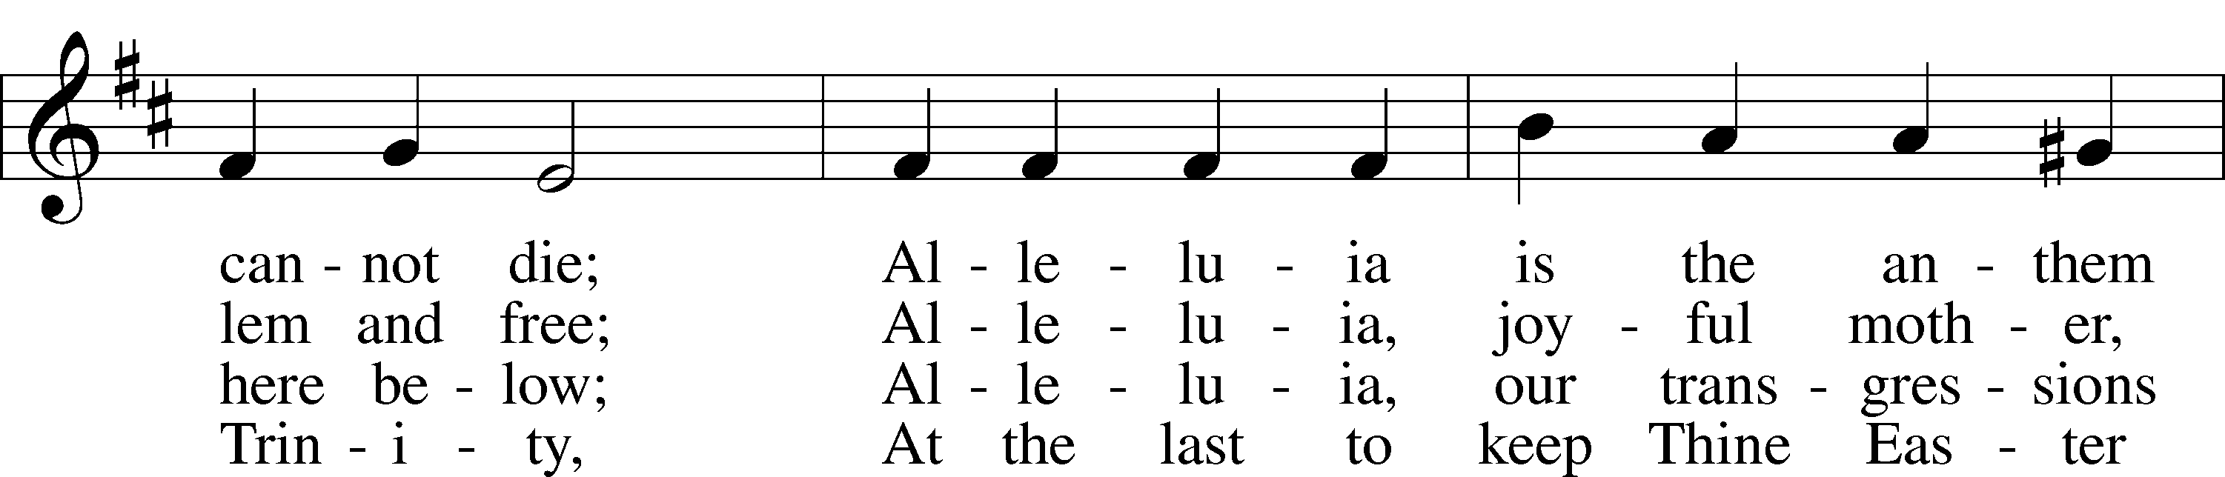
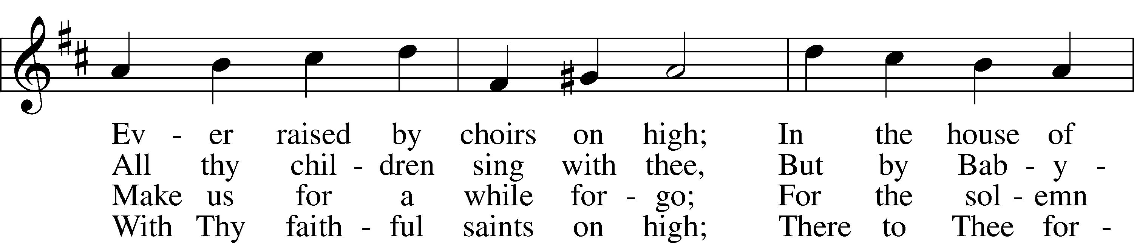
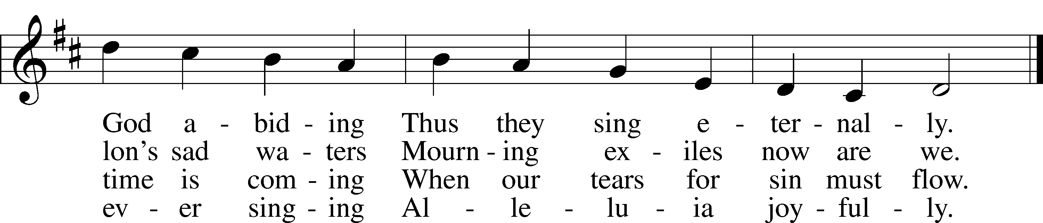
Postlude

Liturgical Note: Pre-Lent begins next Sunday with Septuagesima. This is the little preparatory season that comes before Lent, itself a preparation for Easter. During Pre-Lent and Lent, certain liturgical elements, such as the “Gloria in Excelsis” and the singing of “Alleluias” are omitted as we turn our attention to the Passion of our Lord. Thus, it’s customary to “bid farewell,” as it were, to the Alleluias, since we won’t sing them again until Easter. That’s what our Closing Hymn, Alleluia, Song of Gladness, is all about. It reminds us that—like the Israelites, who hung up their harps and could no longer sing their glad song when taken into Babylonian captivity (Ps. 137)—we must “for a while forego” singing our glad Alleluias. “For the solemn time is coming when our tears for sin must flow.”
Acknowledgments
Divine Service, Setting Two from Lutheran Service Book. Unless otherwise indicated, Scripture quotations are from the ESV® Bible (The Holy Bible, English Standard Version®), copyright © 2001 by Crossway, a publishing ministry of Good News Publishers. Used by permission. All rights reserved. Created by Lutheran Service Builder © 2018 Concordia Publishing House.
1/24 (Transfiguration) 1/31 (Septuagesima)
Pastor | Rev. Willie Grills | Rev. Willie Grills
Organist | Cantor Peter Eckardt | Cantor Peter Eckardt
Head Elder | Brock Montgomery | Brock Montgomery
Assisting Elder | Collin Richey | Collin Richey
Altar Guild | Therese Miller | Therese Miller
Special Music | Adult Choir
Prayer Requests:
Those in Need of Comfort, Health, & Recovery:
Corinne Thomley
Bob Zschau
Herman Janssen
Joyce Schmidt
Kim Henness
In the Military:
Kaitlyn Walker – US Navy
Dylan Haugh - US Marines
If you have a prayer request please email bailey@stjohns-mattoon.org or call the church office at 234-4923.
St. John’s News and Announcements
Church Governing Board (CGB) Meeting: The CGB will have a meeting in the fellowship hall on Monday, January 25 at 7:00 pm. If the chairman of your board or committee is unable to attend, please send another person.
Annual Report- Attention all Church Organizations! All organizations with a checking account, please email your annual report to Bailey at bailey@stjohns-mattoon.org. Any questions please contact the church office at 234-4923.
St. Paul's will begin installing new flooring beginning January 25. As a result they cannot hold worship in their sanctuary for two weeks. Therefore, on January 31 and February 7 two services will be offered at St. John's (8:00 and 10:30am). You may come to the service of your choosing. The congregation at St. Paul's thanks you for your generosity.
Scholarship Fund: Don’t forget we have a scholarship fund you can give to! We will start enrollment for the 2020-2021 school year and financial aid applications on February 1. We would like to help as many kids as possible receive a Christ-centered education here at St. John’s and we don’t want finances to be a reason they aren’t able to come. Determinations are made in the spring.
2020 pecans are still available. Chocolate pecans are $10 per bag. Pecan halves/pieces are $12 per bag. Please call or text Jo Crackel if you would like to purchase (925-451-6189). Thank you.
FIRE Skate Party: The FIRE will have a skate night at Silver Star Skating Rink today from 3:30-6:00 pm. Immediate family is welcome. Please bring $1 for skates. Food will be provided.
Drive-Thru Pancake Breakfast: The FIRE (high school youth group) will have a drive-thru pancake and sausage supper in the u-drive next Sunday, January 31 from 4-7 pm. Donations are welcome for their National Youth Gathering the summer of 2022.
Middle School Youth Group: The Rebels (middle school youth group) will resume in February! Any child in 5th through 8th grade is welcome and encouraged to come join us! We will meet for the first time on February 28 (time and details TBA). Any questions, please call Bailey in the church office (234-4923) or call/text at 690-9014. We have some FUN and EXCITING activities in mind for the year!
St. Peter Lutheran School in St. Peter, Illinois is seeking a 7th/8th grade teacher/principal beginning the 2021/2022 school year. We are a small, farming community located 90 miles East of St. Louis, MO. Interested candidates must be members in good standing of a Missouri Synod congregation, hold (at least) a bachelor's degree with a current state teaching certificate, and be looking for an opportunity to spread God's Word in an educational setting. Concordia University system trained candidates or those willing to commit to completing the Lutheran Teacher Colloquy are preferred, but not required. Please contact: Church Office at 618-349-8321 after 12 p.m.

2021 Offerings:
Budgeted weekly: $7,981
Collected this week: $7,835
Schedule for January 24 – January 31
Sun 8:00am Worship (Transfiguration)
9:10–10:00am Sunday School/Bible Study/Confirmation
6:30pm Men’s Basketball – Gym
3:30–6:00 pm FIRE Skate Party @ Silver Star Skate Rink
Mon 5:30 pm Lutheran School Board
7:00 pm Church Governing Board
Tue 6:30am Men’s Bible Study @Honey Bee Café
Sun 8:00am Worship w/Holy Communion (Septuagesima)
10:30am Worship w/Holy Communion
9:25–10:15am Bible Study/Sunday School/Confirmation
6:30pm Men’s Basketball – Gym
4:00–7:00pm FIRE Pancake Drive-Thru

